Pre-Knowledge Topics Answers:
Symbols and prefixes
- 2400
- 8 100 000
- 326 000 000 000
- 54.6
- 240 000
- 1.8 x 10⁻⁸
- 6.32 x 10⁻⁷
- 1.002
- 5.11 x 10⁻⁵
- 1.1 x 10⁴ or 11x10³

Standard Form:
- 2.53x 10³
- 2.8x10²
- 7.7x10⁻¹
- 9.1x10⁻³
- 1.872x10⁶
- 1.22x10¹
- 240
- 35.05
- 8 310 000
- 600.2
- 0.00015
- 4300

Rearranging formulae
- h= E/ (m x g)
- I = Q/t
- m = (2 x E)/v² or E/(0.5 x v²)
- v= √((2 x E )/m)
- u = v – at
- a = (v-u)/t
- s = (v² – u²) / 2a
- u = √(v²-2as)

Significant figures
- 3.35
- 40.7
- 0.839
- 1.02

- 0.809
- 240 2sf (or 237)
- 3.4
- 0.00330 or 3.30x10⁻³

Atomic Structure
contains protons, neutrons and electrons
Relative charge:
protons are positive (+1)
electrons are negative (-1)
neutrons are uncharged (0)
Relative mass:
proton 1
neutron 1
electron (about) 1/2000
protons and neutrons make up the nucleus
the nucleus is positively charged
electrons orbit the nucleus at a relatively large distance from the nucleus
most of the atom is empty space
nucleus occupies a very small fraction of the volume of the atom
most of the mass of the atom is contained in the nucleus
total number of protons in the nucleus equals the total number of electrons orbiting it in an atom

Recording data
Time should have a unit next to it
Length can be measured to the nearest mm so should be 10.0, 22.0 etc
Length 65 trial 2 is an anomaly and should have been excluded from the mean
All mean values should be to 2 decimal places
Mean of length 51 should be 6.99 (rounding error)
Graphs
Graph 1:
Axis need labels
Point should be x not dots
Line of best fit is needed
y axis is a difficult scale
x axis could have begun at zero so the y-intercept could be found
Graph 2:
y-axis needs a unit
curve of best fit needed not a straight line
Point should be x not dots
Forces and motion
Graph to show acceleration up to a constant speed (labelled terminal velocity). Rate of acceleration should be decreasing. Then a large decrease in velocity over a short period of time (parachute opens), then a decreasing rate of deceleration to a constant speed (labelled terminal velocity)
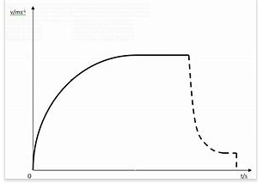

Electricity
1a) Series: 3A, Parallel top to bottom: 4A,2A,2A
b) Less resistance in the parallel circuit. Link to R=V/I. Less resistance means higher current.
2) Series: 3V, 3V, Parallel: 6V 6V

Waves

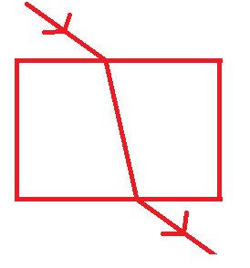
1) When light enters a more optically dense material it slows down and therefore bends towards the normal. The opposite happened when it leaves an optically dense material.

2) A longitudinal wave oscillates parallel to the direction of energy transfer (e.g. sound). A transverse waves oscillated perpendicular to the direction of energy transfer (e.g. light)

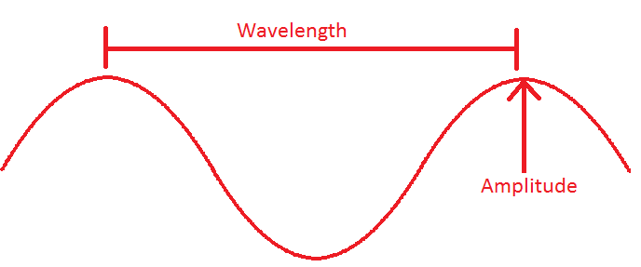
3)
.

A Level Physics Baseline Assessment SUGGEST MARKSCHEME

Q1

Unit prefix | Meaning
k (kilo) | x 1000
μ(micro) | X 0.000001
M (mega) | x 1000000
N (nano) | x 0.000000001 (1x 10⁻⁹)

[3]

Q2

Write the following numbers into standard form

0.012 $1.2×{10}^{-2}$

120000 $1.2×{10}^{5}$

0.00000012 $1.2×{10}^{-7}$

[3]

Complete the following calculations and right your answers to an appropriate number of significant figures.

2.1 X 0.15

0.315 = 0.32(2sf)

0.345 ÷ 0.114

3.0263…= 3.03 (3sf)

Award 1 mark for correct answer and 1 mark for correct number of s.f. [4]

Q3 Re-arrange the following equations to make R the subject of the equation.

$Q=WERTY$

$$R= \frac{Q}{WETY}$$

$Q^{2}=WR^{2}$

$$R=\sqrt{\frac{Q^{2}}{W}}$$

$Q=W-RT^{2}$

$$R=\frac{W-Q}{T^{2}}$$

[3]

Q4

Name the 3 particles (from GCSE) that make up an atom

Proton, Neutron, Electron (any order) [1]

Which one of the above particles is not found in the nucleus of an atom?

Electron [1]

Which of the above particles will be found in varying quantities in the nuclei of isotopes of the same element?

Neutron [1]

Q5

Voltage (V) | Current (A)
Voltage (V) | Repeat 1 | Repeat 2 | Average
2 | 0.23 | 0.26 | 0.25
4 | 0.46 | 0.53 | 0.50
6 | 0.69 | 0.78 | 0.74
8 | 0.92 | 1.04 | 0.98
10 | 1.15 | 1.30 | 1.23

1 Mark for correct unit (V or volts)

1 Mark for correct heading (Current in Amps or A)

1 Mark for correct average, 1 Mark if rounded to correct number of s.f.

[3]

Q6

Use your piece of graph paper to plot a graph of Current (y-axis) against Voltage (x-axis) drawing a line of best fit through your data points.

1 mark if BOTH x and y axis cover half the graph paper

1 mark for correctly labelling x and y axis including units

1 mark if data points are correctly plotted (check 3)

1 mark for correct line of best fit (with even spread of points above and below)

[4]

b) Find the gradient of your line of best fit

Woking must be shown for the award of any marks

1 mark for correct y axis read offs

1 mark for correct x axis read offs

1 mark for correct calculation of their own gradient

[3]

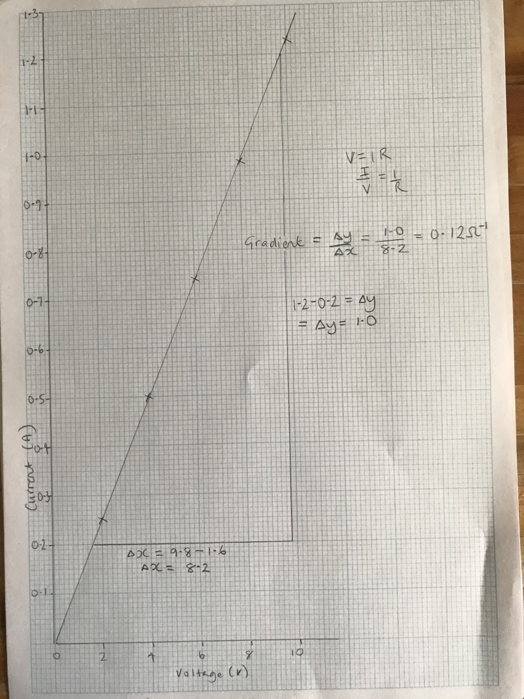

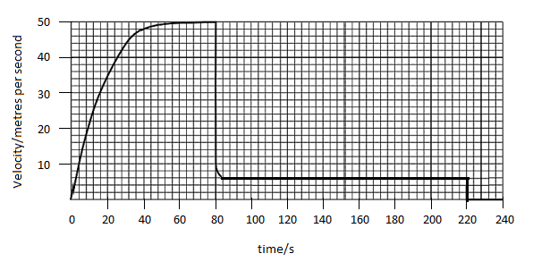
Q7 The graph below shows the journey of a skydiver after they have left the plane.
a) Explain the shape of the graph commenting on how and why the forces have changed.
Band 1 (1/2 Marks) | Band 2 (3/4 Marks) | Band 3 (5/6 Marks)
Correctly describes the motion of the parachutists. E.g. Acceleration (at reducing rate) Terminal velocity/constant speed, deceleration, lower terminal velocity. There may be small errors in spelling and grammar. | Correctly describes motion and links to the balancing and unbalancing of the forces of weight and drag. Almost faultless spelling and grammar. | Explains why increasing velocity produces increased drag and why opening the parachute produces increase drag, using ideas of collisions of air particles with the surface of the skydiver/parachute.  Faultless spelling and grammar
[6]
b) Calculate the distance travelled whilst at the second terminal velocity.

$$\left(220s-84s\right)×6ms^{-1}=816m$$
[2]
c) Calculate the average acceleration in the first 20 seconds.
$\frac{34ms^{-1}}{20s}=1.7$ [1] $ms^{-2}$ [1]
Award 1 mark for correct unit [2]

Q8

Draw a circuit diagram to show how the resistance of a filament bulb could be measured using an ammeter and a voltmeter.

Award 1 mark for correctly positions ammeter [1] and voltmeter [1]

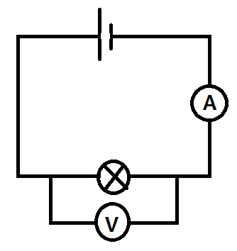

[2]

Look at the circuit diagram below. All of the resistors are identical.

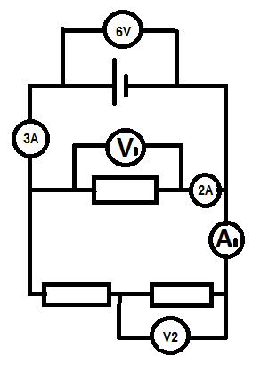

Write the missing values of current and potential difference:

V1 = 6V

V2 = 3V

A1 = 1A

[3]

Q9 The diagram below shows a diagram of 3 complete longitudinal wave oscillations on a slinky:

λ

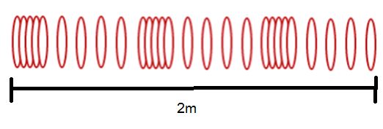λ

State the wavelength of the wave shown

…………………………………………………………2/3m = 0.7m…………………………………………………… [1]

Label a complete wavelength on the diagram above with the correct symbol used for wavelength in GCSE and A Level Physics see diagram λ

[1]

If the above wave had a frequency of 5Hz how long would it take an individual hoop to complete 1 full oscillation?

T = 1/f 1/5 = 0.2s

[1]

d) Calculate the speed of the wave

$$wavespeed=frequency ×wavelength$$

$$wavespeed=5×\frac{2}{3}=3m/s(1sf)$$

Wave speed = ____________ Unit _______[2]

