Approaches: Learning Approaches - Behaviourism
The behaviourist approach is only interested in studying observable and measurable behaviour. Rejects introspection for being too vague and having concepts that are too difficult to measure – prefer the use of lab experiments for more control and objectivity. Behaviourists suggest (thanks to Darwin) that basic processes that govern learning are the same in all species so they use animals as experimental subjects and generalise their findings to humans
Classical Conditioning |  |  | Operant Conditioning
AO1 |  |  | AO1
Explanation | Pavlov’s Research: |  | Explanation |  | Skinner’s Research
Classical conditioning, therefore, involves LEARNING BY ASSOCIATION: simply learning to associate two events which often occur together.  Classical Conditioning = A type of learning which occurs through associations made between the unconditioned stimulus and the neutral stimulus. Before conditioning, the unconditioned stimulus (UCS) produces the unconditioned response (UCR). During conditioning, the neutral stimulus (NS) is repeatedly paired with the UCS, producing an UCR. After conditioning, the neutral stimulus becomes the conditioned stimulus, producing the conditioned response.  Extinction occurs when the conditioned stimulus is no longer paired with the unconditioned stimulus, so the conditioned response becomes extinct/disappears.  Spontaneous recovery occurs when the individual carries out the conditioned response some time after extinction has occurred.  Generalisation occurs when slight changes in the conditioned stimulus, such as different pitches of the bell used in Pavlov’s experiment, still produces the same conditioned response. | Pavlov demonstrated that dogs could be conditioned to salivate upon hearing a bell, as follows:  1. Before conditioning, the unconditioned stimulus (food) produced an unconditioned response (salivation). 2. During conditioning, the unconditioned stimulus was repeatedly paired with a neutral stimulus (a bell), to produce the same unconditioned response of salivation. 3. An association was made between the unconditioned stimulus and the neutral stimulus.  4. After conditioning, the neutral stimulus became the conditioned stimulus, producing the conditioned response of salivation.  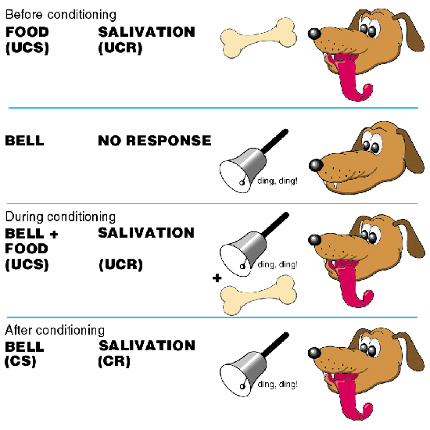 |  | Reinforcers and punishers.  Positive and negative reinforcement increase the likelihood that behaviour will be repeated. Punishment decreases the likelihood that behaviour will be repeated  1. A positive reinforcer is anything pleasurable which increases the probability of a response. E.g. food, warmth, drink, good music.  2. A negative reinforcer is the removal of, or escape from, anything unpleasant which increases the probability of a response occurring. E.g. escape from an electric shock or from being shut up in a small room.  3. A positive punisher is anything unpleasant that decreases the probability that the event proceeding it will occur again. E.g. smacking.  4. A negative punishment is the removal of something pleasant which decreases the likelihood of a response. E.g. removal of pocket money, no television for a week.  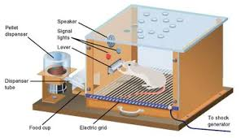 |  | Skinner (1948) studied operant conditioning by conducting experiments using animals which he placed in a 'Skinner Box'.  Beginnings of the Rat & Food Experiment  - In an experiment, a rat was placed in a box and food was used as a reward.  - Over the course of a few days, food was occasionally delivered through an automatic dispenser.  - Before long, the rat approached the food tray as soon as the sound of the dispenser was heard, clearly anticipating the arrival of more food.  The Next Step of the Experiment  - Researchers raised a small lever on the wall of the box and when the rat touched it, the food dispenser provided a snack. After the first self-induced meal, the rat repeatedly touched the lever in order to get more food.  - To the hungry rodent, the sound of the dispenser became a reinforcer, when it was first associated with feedings and continued to be so until after a while, researchers stopped providing food when the lever was pressed. Soon after that, the rat stopped touching the lever.
AO3
P: One strength of the Behaviourist approach is that it has high scientific credibility  E: For example, behaviourism brought language and methods of natural sciences into Psychology by studying observable behaviour in highly controlled lab settings (e.g. Pavlov’s dogs and Skinner’s rats)  E: This is a strength because it emphasises the importance of scientific processes such as objectivity and replication which are key features when defining what a science really is.    L: As a result, the credibility and status of the behaviourist approach is increased. |  | P: One strength of the behaviourist approach is that it has many real-life applications  E: For example, operant conditioning has been used to develop token economy systems in prisons and psychiatric wards (where patients or prisoners are rewarded with tokens that they can exchange for goods when they behave in the desired way), and classical conditioning has been used in the treatment of phobias.  E: This is a strength because it shows that the behaviourist approach is accurate in its assumptions and that we can use these understandings to aid and better the existence of humans to allow for better lifestyles and treatments of potentially debilitating disorders.  L: As a result, the credibility of the behaviourist approach is increased |  | P: One weakness of the behaviourist approach is that it is reductionist.  E: For example it only considers animals, including humans, to be passive and machine-like responders to the environment, with little to no conscious insight into their behaviour.  E: This is a weakness because it fails to consider the complexities of human behaviour. Other approaches such as the social learning theory or the cognitive approach have emphasised the importance of mental events during learning. These processes, which mediate between stimulus and response, suggest that people may play a much more active role in their own learning. This means that learning theory may apply less to human than to animal behaviour.  L: Consequently the credibility of the behaviourist approach is reduced.
Click here for a link to the relevant sub-topic page on Firefly

