
Approaches: Learning Approaches – Social Learning Theory
CC and OC rely on direct experience but we can also learn indirectly by observing the behaviour of others and imitating it (copying it). For behaviour to be imitated it must be seen to be rewarding in some way – vicarious reinforcement (experiencing reinforcement indirectly). Learning is primarily through OBSERVATION, i.e. it is INDIRECT. Individuals observe ROLE MODELS (people with whom they IDENTIFY) and learn about the VALUE of behaviour through indirect or VICARIOUS REINFORCEMENT. These consequences are represented as expectancies of future outcomes and stored as INTERNAL MENTAL REPRESENTATIONS. Observation may lead to learning, but the PERFORMANCE of such behaviours is related to other factors. An individual will in future display a behaviour provided that the expectation of reward is greater that the expectation of punishment and provided the individual has the SKILLS required to perform the behaviour. The behaviour is maintained in the individual’s repertoire if the individual is rewarded for his or her display of the behaviour - DIRECT REINFORCEMENT. In addition to forming expectancies about the likely outcomes of a behaviour, individuals also develop confidence in their ability to carry out the behaviours (SELF-EFFICACY). High self-efficacy increases the likelihood that a behaviour will be repeated
Assumptions | Vicarious Reinforcement |  | Meditational Processes | Identification |  | Bandura’s Research
AO1 | AO1 |  | AO1 | AO1 |  | AO1
Bandura agreed with behaviourists that our behaviour is learned from experience.  However, SLT proposes that we learn through the observation and imitation of others.  So learning can occur both directly (conditioning) but also indirectly.  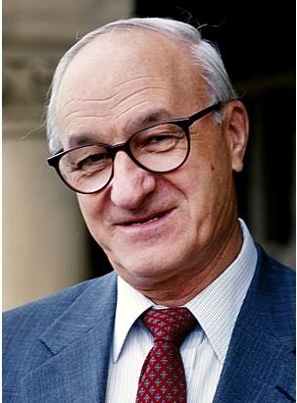 | Indirect learning means an individual observes the behaviour of others.  Imitation is more likely if the behaviour being is observed is rewarded i.e. reinforced rather than punished.  Vicarious reinforcement is therefore when the individual does not directly experience the reward, but they do observe somebody else being rewarded for the behaviour.  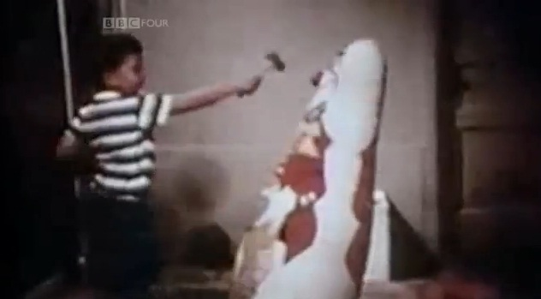 |  | SLT focuses on how mental (cognitive) factors are involved in learning. It states that these mental factors mediate in the learning process to determine whether a new response is required. Bandura identified 4 mediational processes:  1. Attention – someone can only learn through observation if they attend to the model’s behaviour. E.g., children must pay attention to what the aggressor is doing and saying in order to reproduce the model’s behaviour accurately (Allen & Santrock, 1993).  2. Retention – To model the behaviour, it needs to be remembered and placed into LTM, this enables the behaviour to be retrieved.  3. Production – the individual needs to be able to reproduce the behaviour. The observer must possess the physical capabilities of the modelled behaviour.  4. Motivation – an individual expects to receive positive reinforcement for the modelled behaviour. | People (especially children) are much more likely to imitate the behaviour of people with whom they identify with i.e. role models.  This process is called modelling.  A person becomes a role model if they possess similar characteristics to the observer (e.g. age, gender) and/or are attractive and have high status.  Role models may not necessarily be physically present in the environment – this has led to implications for the influence of the media on behaviour e.g. being influenced by violence seen on TV and in video games etc.   |  | Bandura (1961) conducted an experiment to investigate if social behaviours (i.e. aggression) can be acquired by observation and imitation.  A lab experiment was used, in which the independent variable (the type of model) was manipulated in three conditions:  1. Aggressive model is shown to 24 children  2. Non-aggressive model is shown to 24 children  3. No model shown (control condition) - 24 children  The next room contained some aggressive toys including a bobo doll and some non-aggressive toys. The child was in the room for 20 minutes and behaviour was observed and rated though a one-way mirror.  Children who observed the aggressive model made far more imitative aggressive responses. The findings support Bandura's (1977) Social Learning Theory. That is, children learn social behaviour through the process of observation learning - through watching the behaviour of another person.
AO3
P: One strength of Social Learning Theory is that it offers a more adequate account of learning than other behaviourist perspectives  E: For example it considers that humans and other animals do store information about the behaviour of others (by observing) and then use this to make their own judgements about when it is appropriate to perform certain actions (imitation).  E: This is a strength because SLT provides a more comprehensive explanation of learning by recognising these meditational processes. Neither classical nor operant conditioning can offer an adequate account of learning on their own.  L: Consequently, this strengthens the credibility of SLT as an explanation for the learning behaviour of humans and animals.  Click here for a link to the relevant sub-topic page on Firefly |  | P: One weakness of SLT is that research supporting SLT has low ecological validity.  E: For example, Bandura’s Bobo doll study was conducted in a highly controlled lab setting where it did not mirror a real-life setting.  E: This is an issue because if lab studies are not reflective of real-life settings, then demand characteristics may occur. For example, in the Bobo doll study, because the main purpose of the doll is to strike it, the children were simply behaving in a way that they thought was expected. This therefore tells us very little about how children may actually learn behaviours in everyday life.  L: As a result, because the research into SLT has low ecological validity, the credibility of SLT as a theory for how humans learn behaviour is weakened. |  |  | P: One issue with SLT as an explanation for human behaviour is that it is reductionist.  E: For example, SLT states that we simply learn all behaviours from observation of others and then imitating this behaviour in the appropriate social setting.  E: This is an issue because Bandura makes little reference to the impact of biological factors on social learning. One consistent finding in the Bobo doll experiment was that the boys were often more aggressive than girls regardless of the experimental situation. This may be explained by biological, specifically hormonal, factors. Biologically, boys have higher levels of testosterone than girls which is linked to more aggressive behaviour. This biological factor is completely ignored in SLT.  L: Therefore, the credibility of SLT as an explanation for the learning behaviour of humans is reduced.

