Transition Work Pack for A Level Physics
Chellaston Academy Summer 2025
Name ____________________

A guide to help you get ready for A-level Physics, including everything from topic guides to days out and online learning courses

You will need to hand this in, all completed to your Physics Teacher in your first Physics lesson in Year 12

By working through these tasks it will help you be prepared to start year 12 ready for the challenges that face you on the A level Physics OCR A course.
There are suggestions of books to read, films to watch and places to visit that are optional.
There are 3 Non-optional TASKS to complete

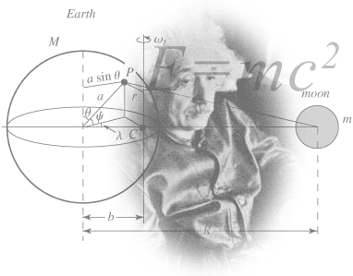
So you are considering A Level Physics?

Figure 1 http://scienceworld.wolfram.com/physics/images/main-physics.gif

This pack contains a programme of activities and resources to prepare you to start an A level in Physics in September. It is aimed to be used after you complete your GCSEs over the Summer Holidays to ensure you are ready to start your course in September.
Your teachers will be
Mrs Jepson – Head of Physics contact email - emmajepson@chellaston.derby.sch.uk
Miss Winter Mr Whetton Mr Wheat

The OCR Physics A year 12 Text book and other stuff to sort for the start of year 12
To be ready for to start year 12 you will need to have sorted a number of things.
- 1. You will need to have a folder organised just for A level Physics. You will need to keep it organised. To help with this you must have dividers to split the work from your different teachers. You will have at least 2 teachers for Physics.
- 2. You will need to have completed all of this transition booklet and marked/corrected it in red pen using the answers on the Transition pages on Firefly and bring it in with you for your first Physics lesson.
- 3. You will need to have purchased the year 12 OCR A level Text book
See information below.

OCR AS/A level Physics A Student Book 1 + ActiveBook (OCR GCE Science 2015)

by Mike O'Neil
Created for the new 2015 OCR AS and A level specifications, our new Student Books cover the topics comprehensively, developing scientific thinking in your students, providing them with a deep understanding of the subject and creating confident, independent scientists.
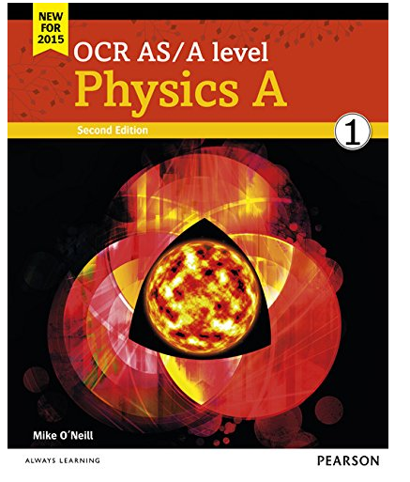

Book Recommendations - Optional
Below is a selection of books that should appeal to a physicist – someone with an enquiring mind who wants to understand the universe around us. None of the selections are textbooks full of equation work (there will be plenty of time for that!) instead each provides insight to either an application of physics or a new area of study that you will be meeting at A Level for the first time.
- Surely You're Joking Mr Feynman: Adventures of a Curious Character
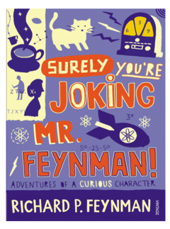
ISBN - 009917331X - Richard Feynman was a Nobel Prize winning Physicist. In my opinion he epitomises what a Physicist is. By reading this books you will get insight into his life’s work including the creation of the first atomic bomb and his bongo playing adventures and his work in the field of particle physics.
(Also available on Audio book). https://www.waterstones.com/books/search/term/surely+youre+joking+mr+feynman++adventures+of+a+curious+character


Moondust: In Search of the Men Who Fell to Earth

ISBN – 1408802384 - One of the greatest scientific achievements of all time was putting mankind on the surface of the moon. Only 12 men made the trip to the surface, at the time of writing the book only 9 are still with us. The book does an excellent job of using the personal accounts of the 9 remaining astronauts and many others involved in the space program at looking at the whole space-race era, with hopefully a new era of space flight about to begin as we push on to put mankind on Mars in the next couple of decades.

https://www.waterstones.com/books/search/term/moondust++in+search+of+the+men+who+fell+to+earth

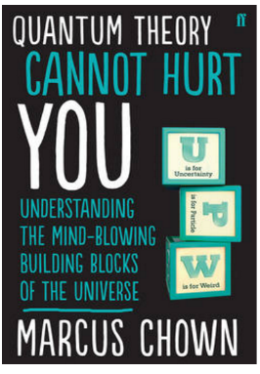
Quantum Theory Cannot Hurt You: Understanding the Mind-Blowing Building Blocks of the Universe

ISBN - 057131502X - Any Physics book by Marcus Chown is an excellent insight into some of the more exotic areas of Physics that require no prior knowledge. In your first year of A-Level study you will meet the quantum world for the first time. This book will fill you with interesting facts and handy analogies to whip out to impress your peers!

https://www.waterstones.com/book/quantum-theory-cannot-hurt-you/marcus-chown/9780571315024


A Short History of Nearly Everything

ISBN – 0552997048 - A modern classic. Popular science writing at its best. A Short History of Nearly Everything Bill Bryson’s quest to find out everything that has happened from the Big Bang to the rise of civilization - how we got from there, being nothing at all, to here, being us. Hopefully by reading it you will gain an awe-inspiring feeling of how everything in the universe is connected by some fundamental laws.

https://www.waterstones.com/books/search/term/a+short+history+of+nearly+everything

Thing Explainer: Complicated Stuff in Simple Words

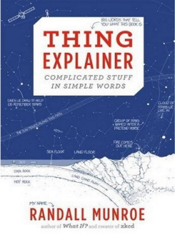
ISBN – 1408802384 - This final recommendation is a bit of a wild-card – a book of illustrated cartoon diagrams that should appeal to the scientific side of everyone. Written by the creator of online comic XTCD (a great source of science humour) is a book of blueprints from everyday objects such as a biro to the Saturn V rocket and an atom bomb, each one meticulously explained BUT only with the most common 1000 words in the English Language. This would be an excellent coffee table book in the home of every scientist.

https://www.waterstones.com/book/thing-explainer/randall-munroe/9781473620919

Movie / Video Clip Recommendations - Optional

Hopefully you’ll get the opportunity to soak up some of the Sun’s rays over the summer – synthesising some important Vitamin-D – but if you do get a few rainy days where you’re stuck indoors here are some ideas for films to watch or clips to find online.

Science Fictions Films

Moon (2009)

Gravity (2013)

Interstellar (2014)

The Imitation Game (2015)

The Prestige (2006)

Online Clips / Series

Minute Physics – Variety of Physics questions explained simply (in felt tip) in a couple of minutes. Addictive viewing that will have you watching clip after clip – a particular favourite of mine is “Why is the Sky Dark at Night?”

https://www.youtube.com/user/minutephysics

Wonders of the Universe / Wonders of the Solar System – Both available of Netflix as of 17/4/16 – Brian Cox explains the Cosmos using some excellent analogies and wonderful imagery.

Shock and Awe, The Story of Electricity – A 3 part BBC documentary that is essential viewing if you want to see how our lives have been transformed by the ideas of a few great scientists a little over 100 years ago. The link below takes you to a stream of all three parts joined together but it is best watched in hourly instalments. Don’t forget to boo when you see Edison. (alternatively watch any Horizon documentary – loads of choice on Netflix and the I-Player)

https://www.youtube.com/watch?v=Gtp51eZkwoI

NASA TV – Online coverage of launches, missions, testing and the ISS. Plenty of clips and links to explore to find out more about applications of Physics in Space technology.

http://www.nasa.gov/multimedia/nasatv/

Research activity NON-OPTIONAL TASK 1
To get the best grades in A Level Physics you will have to get good at completing independent research and making your own notes on difficult topics. Below are links to 5 websites that cover some interesting Physics topics.
Using the Cornell notes system: http://coe.jmu.edu/learningtoolbox/cornellnotes.html make 1 page of notes from 2 sites – you choose! covering topics of your choice. – see diagram at the end of this section to show you the layout of your notes.
- http://home.cern/about
CERN encompasses the Large Hadron Collider (LHC) and is the largest collaborative science experiment ever undertaken. Find out about it here and make a page of suitable notes on the accelerator. – At Chellaston Academy we offer a trip here in the Summer of Year 12.
- http://joshworth.com/dev/pixelspace/pixelspace_solarsystem.html
The solar system is massive and its scale is hard to comprehend. Have a look at this award winning website and make a page of suitable notes.
- https://phet.colorado.edu/en/simulations/category/html
PhET create online Physics simulations when you can complete some simple experiments online. Open up the resistance of a wire html5 simulation. Conduct a simple experiment and make a one page summary of the experiment and your findings.
- http://climate.nasa.gov/
NASA’s Jet Propulsion Laboratory has lots of information on Climate Change and Engineering Solutions to combat it. Have a look and make notes on an article of your choice.
- http://www.livescience.com/46558-laws-of-motion.html
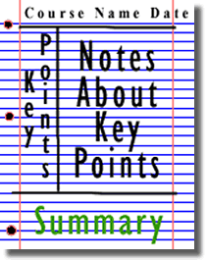
Newton’s Laws of Motion are fundamental laws for the motion of all the object we can see around us. Use this website and the suggested further reading links on the webpage to make your own 1 page of notes on the topics.

Figure 2: http://coe.jmu.edu/learningtoolbox/images/noteb4.gif

Pre-Knowledge Topics NON-OPTIONAL TASK 2
You will need to mark/correct this using red pen and answers found on Transition pages
Below are ten topics that are essential foundations for you study of A-Level Physics. Each topics has example questions and links where you can find our more information as you prepare for next year.

Symbols and Prefixes
Prefix | Symbol | Power of ten
Nano | n | x 10⁻⁹
Micro | μ | x 10⁻⁶
Milli | m | x 10⁻³
Centi | c | x 10⁻²
Kilo | k | x 10³
Mega | M | x 10⁶
Giga | G | x 10⁹

At A level, unlike GCSE, you need to remember all symbols, units and prefixes. Below is a list of quantities you may have already come across and will be using during your A level course
Quantity | Symbol | Unit
Velocity | v | ms⁻¹
Acceleration | a | ms⁻²
Time | t | s
Force | F | N
Resistance | R | Ω
Potential difference | V | V
Current | I | A
Energy | E or W | J
Pressure | P | Pa or Nm⁻²
Momentum | p | kgms⁻¹
Power | P | W
Density | ρ | kgm⁻³
Charge | Q | C

Solve the following:
- How many metres in 2.4 km?

- How many joules in 8.1 MJ?

- Convert 326 GW into W.

- Convert 54 600 mm into m.

- How many grams in 240 kg?

- Convert 0.18 nm into m.

- Convert 632 nm into m. Express in standard form.

- Convert 1002 mV into V. Express in standard form.

- How many eV in 0.511 MeV? Express in standard form.

- How many m in 11 km? Express in standard form.

Standard Form
At A level quantity will be written in standard form, and it is expected that your answers will be too.
This means answers should be written as ….x 10^{y}. E.g. for an answer of 1200kg we would write 1.2 x 10³kg. For more information visit: https://www.bbc.com/bitesize/guides/z8skqhv/revision/1

- Write 2530 in standard form.

- Write 280 in standard form.

- Write 0.77 in standard form.

- Write 0.0091 in standard form.

- Write 1 872 000 in standard form.

- Write 12.2 in standard form.
- Write 2.4 x 10 ² as a normal number.

- Write 3.505 x 10 ¹ as a normal number.

- Write 8.31 x 10 ⁶ as a normal number.

- Write 6.002 x 10 ² as a normal number.

- Write 1.5 x 10⁻⁴ as a normal number.

- Write 4.3 x 10³ as a normal number.

Rearranging formulae
This is something you will have done at GCSE and it is crucial you master it for success at A level. For a recap of GCSE watch the following link:
www.youtube.com/watch?v=_WWgc3ABSj4

Rearrange the following:

- E=m x g x h to find h

- Q= I x t to find I

- E = ½ m v² to find m

- E = ½ m v² to find v

- v = u + at to find u

- v = u + at to find a

- v² = u² +2as to find s

- v² = u² +2as to find u

Significant figures

At A level you will be expected to use an appropriate number of significant figures in your answers. The number of significant figures you should use is the same as the number of significant figures in the data you are given. You can never be more precise than the data you are given so if that is given to 3 significant your answer should be too. E.g. Distance = 8.24m, time = 1.23s therefore speed = 6.75m/s

The website below summarises the rules and how to round correctly.
http://www.purplemath.com/modules/rounding2.htm

Give the following to 3 significant figures:

- 3.4527
- 40.691
- 0.838991
- 1.0247
- 59.972

Calculate the following to a suitable number of significant figures – You use the least significant figures from your data.

- 63.2/78.1
- 39+78+120
- (3.4+3.7+3.2)/3
- 0.0256 x 0.129
- 592.3/0.1772

Atomic Structure
You will study nuclear decay in more detail at A level covering the topics of radioactivity and particle physics. In order to explain what happens you need to have a good understanding of the model of the atom. You need to know what the atom is made up of, relative charges and masses and how sub atomic particles are arranged.

The following video explains how the current model was discovered www.youtube.com/watch?v=wzALbzTdnc8

Describe the model used for the structure of an atom including details of the individual particles that make up an atom and the relative charges and masses of these particles. You may wish to include a diagram and explain how this model was discovered by Rutherford

Recording Data
Whilst carrying out a practical activity you need to write all your raw results into a table. Don’t wait until the end, discard anomalies and then write it up in neat.
Tables should have column heading and units in this format quantity/unit e.g. length /mm
All results in a column should have the same precision and if you have repeated the experiment you should calculate a mean to the same precision as the data.

Below are link to practical handbooks so you can familiarise yourself with expectations.

http://www.ocr.org.uk/Images/295483-practical-skills-handbook.pdf

Below is a table of results from an experiment where a ball was rolled down a ramp of different lengths. A ruler and stop clock were used.

1) Identify the errors the student has made.

 | Time
Length/cm | Trial 1 | Trial 2 | Trial 3 | Mean
10 | 1.45 | 1.48 | 1.46 | 1.463
22 | 2.78 | 2.72 | 2.74 | 2.747
30 | 4.05 | 4.01 | 4.03 | 4.03
41 | 5.46 | 5.47 | 5.46 | 5.463
51 | 7.02 | 6.96 | 6.98 | 6.98
65 | 8.24 | 9.68 | 8.24 | 8.72
70 | 9.01 | 9.02 | 9.0 | 9.01

Graphs

After a practical activity the next step is to draw a graph that will be useful to you. Drawing a graph is a skill you should be familiar with already but you need to be extremely vigilant at A level. Before you draw your graph to need to identify a suitable scale to draw taking the following into consideration:

- the maximum and minimum values of each variable
- whether 0.0 should be included as a data point; graphs don’t need to show the origin, a false origin can be used if your data doesn’t start near zero.
- the plots should cover at least half of the grid supplied for the graph.
- the axes should use a sensible scale e.g. multiples of 1,2, 5 etc)

Identify how the following graphs could be improved

Graph 1 Graph 2
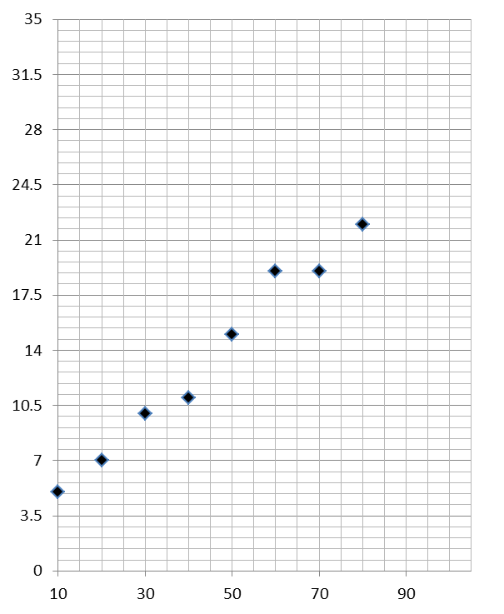

Forces and Motion
At GCSE you studied forces and motion and at A level you will explore this topic in more detail so it is essential you have a good understanding of the content covered at GCSE. You will be expected to describe, explain and carry calculations concerning the motion of objects. The website below cover Newton’s laws of motion and have links to these in action.

http://www.physicsclassroom.com/Physics-Tutorial/Newton-s-Laws
Sketch a velocity-time graph showing the journey of a skydiver after leaving the plane to reaching the ground.
Mark on terminal velocity.

Electricity
At A level you will learn more about how current and voltage behave in different circuits containing different components. You should be familiar with current and voltage rules in a series and parallel circuit as well as calculating the resistance of a device.

http://www.allaboutcircuits.com/textbook/direct-current/chpt-1/electric-circuits/
http://www.physicsclassroom.com/class/circuits

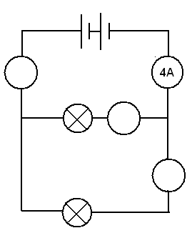
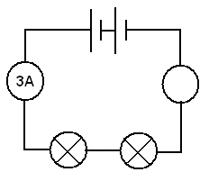
1a) Add the missing ammeter readings on the circuits below, assume the bulbs are identical.

b) Explain why the second circuit has more current flowing than the first.

2) Add the missing potential differences to the following circuits, assume the bulbs are identical.
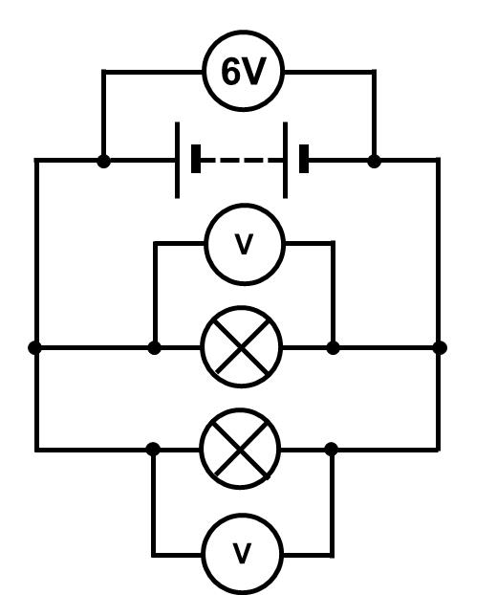
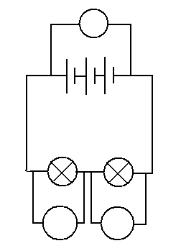
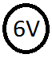

Waves
You have studied different types of waves and used the wave equation to calculate speed, frequency and wavelength. You will also have studied reflection and refraction.
Use the following links to review this topic.
https://www.bbc.com/bitesize/topics/zcwkgdm
1) Draw a diagram showing the refraction of a wave through a rectangular glass block. Explain why the ray of light takes this path.

2) Describe the difference between a longitudinal and transverse waves and give an example of each

3) Draw a transverse wave and label the wavelength and amplitude, peak and trough. Draw a longitudinal wave and label the wavelength, compression and rarefaction.

Ideas for Day Trips - Optional

Here are some suggestions for some physics-themed days out for you to enjoy over the summer break. Try and have some fun as you prepare for two tough but rewarding years ahead!

Northern England and Scotland

Jodrell Bank Observatory – Cheshire – one of the largest moveable radio telescopes in the world and the location of the filming of the BBC’s Stargazing Live. The site has both indoor and outdoor activities.

MOSI – Manchester – Massive free museum showing how science helped Britain lead the way through the industrial revolution. Contains hands on exhibits and displays and often host regular travelling exhibitions.

Liverpool World Museum / Spaceport – Liverpool/Wirral – Start the day off at an excellent family science museum with a top floor dedicated to astronomy including a planetarium. Take the ferry cross the Mersey to another family friendly museum dedicated to spaceflight.

Kielder Observatory – Northumberland – Book ahead at this popular observatory in the midst of the darkest night skies the UK has to offer. Regular tours and opportunities to view the stars through professional telescopes take place on a nightly basis.

Glasgow Science Centre - The Centre is home to hundreds of interactive exhibits throughout the three engaging floors

The Midlands and Wales

Electric Mountain – Snowdonia – Set against a mountainous backdrop is a working pumped storage power station. Take a tour deep into the heart of the mountain and see the turbines spring into action to meet our ever increasing demand for electricity. Take a stroll up on of the UKs highest peaks in the afternoon.

National Space Centre – Leicester - With six interactive galleries, the UK’s largest planetarium, unique 3D Simulator experience, the award-winning National Space Centre in Leicester is an out of this world visitor attraction

Alton Towers – Staffordshire – Treat yourself to a go on a few rollercoasters whilst discussing Newton’s Laws. You may want to download and take these handy rollercoaster physics notes with you http://www.explainthatstuff.com/rollercoasters.html

Southern England

Royal Observatory – London - Visit the Royal Observatory Greenwich to stand on the historic Prime Meridian of the World, see the home of Greenwich Mean Time (GMT), and explore your place in the universe at London’s only planetarium.

Herschel Museum of Astronomy – Bath – As you walk around the picturesque Roman city – take an hour or two out at the home of one of the great scientists – discoverer of Infra-red radiation and Uranus.

@Bristol – Bristol - home to the UK’s only 3D Planetarium and one of the biggest science centres.

The Royal Institution – London – The birthplace of many important ideas of modern physics, including Michael Faraday’s lectures on electricity. Now home to the RI Christmas lectures and many exhibits of science history.

A Level Physics Transition Baseline Assessment
NON-OPTIONAL TASK 3 You will need to mark/correct this using red pen and answers found on Transition pages

40 Marks – 40 Minutes
A single piece of graph paper may be required for the completion of the assessment. You will then need to go onto the Physics Transition pages and use the markscheme to mark and correct your work in red pen
You may use a calculator.

Question Number | Topic | Score
1 | Symbols and Prefixes | /3
2 | Standard Form | /4
3 | Re-arranging Equations | /3
4 | Atomic Structure | /3
5 | Recording Data | /3
6 | Graphing | /4
7 | Forces and Motion | /10
8 | Electrical Circuits | /5
9 | Waves | /5
 |  | Total /40

Q1 Complete the following table:
Unit prefix | Meaning
k (kilo) | x 1000
 | X 0.000001

M (mega)

N (nano)

[3]

Q2

Write the following numbers into standard form.

0.012

120000

0.00000012

[3]

Complete the following calculations and right your answers to an appropriate number of significant figures.

2.1 X 0.15

0.345 ÷ 0.114

[4]

Q3 Re-arrange the following equations to make R the subject of the equation.

$Q=WERTY$

$Q^{2}=WR^{2}$

$Q=W-RT^{2}$

[3]

Q4 Name the 3 particles (from GCSE) that make up an atom.

……………………………………………………………………………………………………………………………………………… [1]

Which one of the above particles is not found in the nucleus of an atom?

……………………………………………………………………………………………………………………………………………… [1]

Which of the above particles will be found in varying quantities in the nuclei of isotopes of the same element?

……………………………………………………………………………………………………………………………………………… [1]

Q5

Complete the following table
Voltage (__) | __________ (A)
Voltage (__) | Repeat 1 | Repeat 2 | Average
2 | 0.23 | 0.26 | 0.25
4 | 0.46 | 0.53
6 | 0.69 | 0.78 | 0.74
8 | 0.92 | 1.04 | 0.98
10 | 1.15 | 1.30 | 1.23

[3]

Q6

a) Use your piece of graph paper to plot a graph of Current (x-axis) against Voltage (y-axis) drawing a line of best fit through your data points.

[4]

b) Find the gradient of your line of best fit

[3]

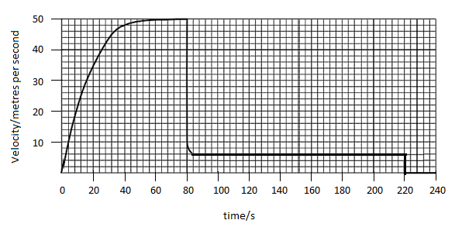
Q7 The graph below shows the journey of a skydiver after they have left the plane.
a) Explain the shape of the graph commenting on how and why the forces have changed.
______________________________________________________________________________________________________________________________________________________________________________________________________________________________________________________________________________________________________________________________________________________________________________________________________________________________________________________________________________________________________________________________________________________________________________________________________________________________________________________________________________________________________________________________________________________________________________________________________________________________________________________________________________________________________________________________________________________________________________________________________________________________________________________________________________________________________________________________________________________________________________________________________________________________________________________________________________________________________________________________________________________________________________________________________
[6]

b) Calculate the distance travelled whilst at the second terminal velocity.

[2]
c) Calculate the average acceleration in the first 20 seconds.

[2]

Q8

Draw a circuit diagram to show how the resistance of a filament bulb could be measured using an ammeter and a voltmeter.

[2]

Look at the circuit diagram below. All of the resistors are identical.

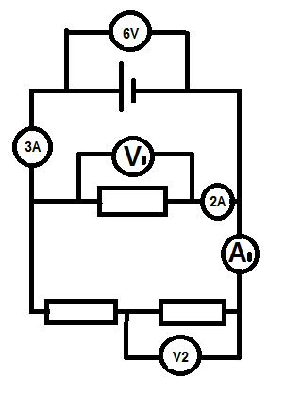

Write the missing values of current and potential difference:

V1 =

V2 =

A1 =

[3]

Q9 The diagram below shows a diagram of 3 complete longitudinal wave oscillations on a slinky:

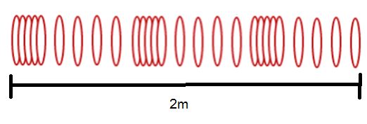

State the wavelength of the wave shown

…………………………………………………………………………………………………………………………………………………… [1]

Label a complete wavelength on the diagram above with the correct symbol used for wavelength in GCSE and A Level Physics

[1]

If the above wave had a frequency of 5Hz how long would it take an individual hoop to complete 1 full oscillation?

[1]

d) Calculate the speed of the wave

$$wavespeed=frequency ×wavelength$$

Wave speed = ____________ Unit _______[2]

