Get ready
for A Level Physics
Chellaston Academy Summer 2025
Name ____________________

Get ready for A-level!

Guide to help you get ready for A-level Physics at Chellaston Academy
So you are considering A Level Physics?

Your teachers will be
Mrs Jepson – Head of Physics contact email - e.jepson@chellaston.derby.sch.uk
Miss Winter
Mr Whetton
Mr Wheat

The OCR Physics A year 12 Text book and other stuff to sort for the start of year 12
To be ready for to start year 12 you will need to have sorted a number of things.
- You will need to have a folder organised just for A level Physics. You will need to keep it organised. To help with this you must have dividers to split the work from your different teachers. You will have at least 2 teachers for Physics.

- You will need to have completed and marked and corrected all of the transition booklet which is a separate document called -

- ‘Transition Pack - A Level Physics JEP 2025’

- Bring it in with you for your first Physics lesson.

- There are suggested places to visit!! you can go on virtual tours of lots of them
- You will need to have purchased the year 12 OCR A level Text book
See information below.

OCR AS/A level Physics A Student Book 1 + ActiveBook (OCR GCE Science 2015)

by Mike O'Neill
Created for the new 2015 OCR AS and A level specifications, our new Student Books cover the topics comprehensively, developing scientific thinking in your students, providing them with a deep understanding of the subject and creating confident, independent scientists.
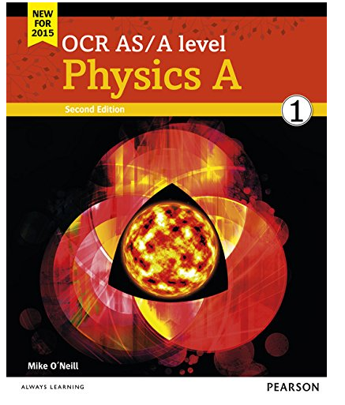
Publisher: Pearson Education Limited
ISBN: 9781447990826
Number of pages: 296

https://www.waterstones.com/product/ocr-as-a-level-physics-a-student-book-1-activebook/mike-oneill//9781447990826?awaid=3787&utm_source=redbrain&utm_medium=shopping&utm_campaign=css&gclid=Cj0KCQjw7qn1BRDqARIsAKMbHDZTtLJG1klfyrFyoLXayY8rg-ez-WDqG5vdPQFkwQW18eBfwkInp3caAutVEALw_wcB&awc=3787_1588271831_04a559f9e9f21f4ba9eaefe97b593fe5

https://www.amazon.co.uk/level-Physics-Student-ActiveBook-Science/dp/144799082X

Obviously it is useful to have revision guides to help you so any that are OCR Physics A Syllabus from 2015 onwards would be great.

Hope to see you soon,
Mrs Jepson

Assessment Overview
Modelling Physics (01)  100 Marks  2 hours 15 min  Covers modules1, 2, 3 and 5 | 37% of total A-Level
Exploring Physics (02)  100 marks  2 hour 15 min  Covers modules 1, 2, 4 and 6 | 37% of total A-Level
Unified Physics (03)  70 marks  Covers modules 1-6 | 26% of total A-Level
Practical endorsement in Physics (04)  Non exam assessment | Reported Separately

