**­­**



**Independent skills:**

**Chemistry** – **Student Booklet**

**KS5**

**Atomic Structure**

**Contents:**

1. Level 1- Multiple Choice Quiz – 20 credits
2. Level 2 - 5 questions, 5 sentences, 5 words – 10 credits each
3. Level 3 - Science in The News – 100 credits
4. Level 4 - Scientific Poster – 100 credits
5. Level 5 - Video summaries – 50 credits each

**Independent skills – Level 1**

**Multiple Choice Questions**

**A Level Chemistry – Atomic Structure**

|  |
| --- |
| **INSTRUCTIONS Score: /20** |

* **Read the question carefully.**
* **Circle the correct letter.**
* **Answer all questions**

|  |  |  |
| --- | --- | --- |
| 1. | What does the mass number tell you? | |
|  | a. | Total number of neutrons and electrons in an atom. |
|  | b. | Total number of electrons and protons in an atom. |
|  | c. | Total number of neutrons in an atom. |
|  | d. | Total number of protons and neutrons in an atom. |
| 2. | What does the term ‘relative isotopic mass’ mean? | |
|  | a. | Average mass of an atom of an element compared to Carbon14. |
|  | b. | Mass of an isotope compared to carbon. |
|  | c. | Average mass of an atom of an element compared to Carbon12. |
|  | d. | Mass of an atom of an isotope compared to Carbon12. |
| 3. | Which of these is an isotope of chlorine | |
|  | a. | Cl- |
|  | b. | 37Cl |
|  | c. | 35.5Cl |
|  | d. | Cl+ |
| 4. | The element vanadium has an atomic number of 23, and a mass number of 51.  Determine the number of each subatomic particle in an atom of vanadium. | |
|  | a. | Electrons = 23; Protons = 51; Neutrons = 23 |
|  | b. | Electrons = 23; Protons = 28; Neutrons = 23 |
|  | c. | Electrons = 23; Protons = 23; Neutrons = 28 |
|  | d. | Electrons = 23; Protons = 23; Neutrons = 51 |
| 5. | Vanadium has a number of different oxidation states. Which if the following statements is FALSE for V3+? | |
|  | a. | It contains 26 electrons. |
|  | b. | It contains 23 protons. |
|  | c. | It contains 20 electrons. |
|  | d. | It is an ion. |
| 6. | Which of the following statements is FALSE? | |
|  | a. | Isotopes are atoms of an element with a different number of neutrons. |
|  | b. | Isotopes are atoms of an element with a different mass. |
|  | c. | Isotopes are atoms of an element with a different number of protons. |
|  | d. | Isotopes are atoms of an element with a different mass number. |
| 7. | Mass spectrometry can be used to determine relative atomic mass. Look at the following diagram and determine the relative atomic mass of the substance. | |
|  | a. | 91.36 |
|  | b. | 9136 |
|  | c. | 96 |
|  | d. | 90 |
| 8. | The following data was gathered using mass spectrometry. Determine the relative atomic mass to 4 significant figures.   |  |  | | --- | --- | | Isotope | Relative abundance / % | | 24Mg | 78.99 | | 25Mg | 10.00 | | 26Mg | 11.01 | | |
|  | 1. 24.3 | |
|  | 1. 24.32 | |
|  | 1. 24.3202 | |
|  | 1. 24 | |
|  |  | |
| 9. | Calculate the relative formula mass of NH3 using the periodic table on your examination board data sheet. | |
|  | a. | 10 |
|  | b. | 10.0 |
|  | c. | 43.0 |
|  | d. | 17.0 |
|  |  | |
| 10. | What is the full electron configuration for an oxygen ion; O2- ? | |
|  | a. | 1s22s22p4 | |
|  | b. | 1s22s22p6 | |
|  | c. | 1s22s22p1 | |
|  | d. | 1s22s22p2 | |
|  |  |  | |
| 11. | What is the full electron configuration for krypton, Kr? | |
|  | a. | [Ar] 3d10 4s2 4p6 |
|  | b. | [Ar] 3d10 4s2 4p7 |
|  | c. | 1s22s22p63s23p64s23d104p6 |
|  | d. | Answers a & c |
|  |  | |
| 12. | The following definition applies to which of the terms below?  ‘The energy needed to remove an electron from each atom in 1 mole of gaseous atoms. Forming 1 mole of gaseous 1+ ions.’ | |
|  | a. | Electron energy |
|  | b. | Ionisation energy |
|  | c. | First ionisation energy |
|  | d. | Second ionization energy |
|  |  | |
| 13. | Which of the following is NOT a factor which affects ionisation energy? | |
|  | a. | Relative molecular mass |
|  | b. | Nuclear charge |
|  | c. | Shielding |
|  | d. | Distance from nucleus |
|  |  | |
| 14. | The symbol for atomic number is… | |
|  | a. | M |
|  | b. | Z |
|  | c. | m |
|  | d. | A |
|  |  | |
| 15. | Which of the following shows the shape of an s-orbital? | |
|  | a. |  |
|  | b. |  |
|  | c. |  |
|  | d. |  |
|  |  | |
| 16. | How many electrons in an oxygen ion, O2-? | |
|  | a. | 16 |
|  | b. | 8 |
|  | c. | 10 |
|  | d. | 6 |
|  |  | |
| 17. | Boron has two isotopes. One is 10B with an abundance of 18.92%. Which is the other isotope? | |
|  | a. | 11B |
|  | b. | 13B |
|  | c. | 12B |
|  | d. | 9B |
|  |  | |
| 18. | What is the equation for the second ionisation of oxygen? | |
|  | a. | O+O2++ e- |
|  | b. | O+(g) O2+(g) + e- |
|  | c. | O+(g) O2+(g) + 2e- |
|  | d. | O-(g) O2-(g) + e- |
|  |  | |
| 19. | Which statement below describes the first ionisation energy down a group? | |
|  | a. | It decreases because there are fewer protons in the nucleus. |
|  | b. | It increases because there are fewer protons in the nucleus. |
|  | c. | It decreases because the outer electron is further from the nucleus. |
|  | d. | It increases because the outer electron is further from the nucleus. |
|  |  | |
| 20. | Which statement below describes the first ionisation energy across a period? | |
|  | a. | It decreases because there are more protons in the nucleus. |
|  | b. | It increases because there are fewer protons in the nucleus. |
|  | c. | It decreases because the outer electron is further from the nucleus. |
|  | d. | It increases because there are more protons in the nucleus. |
|  |  | |

**Independent skills – Level 2**

**5 questions, 5 sentences, 5 words**

**A Level Chemistry – Atomic Structure**

|  |
| --- |
| **INSTRUCTIONS** |

* **For each statement, use either the suggested website or your own text book to write a 5-point summary. In examinations, answers frequently require more than 1 key word for the mark, so aim to include a few key words.**
* **It is important to stick to 5 sentences. It is the process of selecting the most relevant information and summarizing it, that will help you remember it.**
* **Write concisely and do not elaborate unnecessarily, it is harder to remember and revise facts from a big long paragraph.**
* **Finally, identify 5 key words that you may have difficulty remembering and include a brief definition. You might like to include a clip art style picture to help you remember it.**

**Example:**

|  |  |  |  |  |  |
| --- | --- | --- | --- | --- | --- |
| **QUESTION:** | **What is inside an atom?** | | | | |
| **Sources:** | 1. **Website –** <http://chemguide.co.uk/atoms/properties/gcse.html> 2. **Website –** <http://www.s-cool.co.uk/a-level/chemistry/atomic-structure/revise-it/the-structure-of-the-atom> | | | | |
| 1. **Proton – this has a relative charge of +1 and a relative mass of 1.** 2. **Neutron – this has no charge and a relative mass of 1.** 3. **Electron - this has a relative charge of -1 and a relative mass of 1/1836** 4. **Electrons are found at different energy levels around the nucleus, these energy levels can be broken down into sub-shells.** 5. **Electrons are found in orbitals which can hold a maximum of 2 electrons, these can be s, p, d and f types.** | | | | | |
| **Proton – +1, 1.** | | **Neutron – no charge, 1.** | **Electron -1, 1/1836.** | **Energy levels & sub-shells** | **s, p, d, f orbitals** |

|  |  |  |  |  |  |
| --- | --- | --- | --- | --- | --- |
| **QUESTION 1:** | **Electrons are found in regions called orbitals. Describe the main features of the s, p and d orbitals.** | | | | |
| **Sources:** | **Website –**   1. <http://chemguide.co.uk/atoms/properties/atomorbs.html> 2. <https://socratic.org/chemistry/the-electron-configuration-of-atoms/arrangement-of-electrons-in-orbitals-spd-and-f> | | | | |
|  | | | | | |
|  | |  |  |  |  |

|  |  |  |  |  |  |
| --- | --- | --- | --- | --- | --- |
| **QUESTION 2:** | **Describe the main factors which affect the size of an ionisation energy.** | | | | |
| **Sources:** | **Website –**   1. <http://www.s-cool.co.uk/a-level/chemistry/atomic-structure/revise-it/ionisation-energy> 2. <http://chemguide.co.uk/atoms/properties/ies.html> | | | | |
|  | | | | | |
|  | |  |  |  |  |

|  |  |  |  |  |  |
| --- | --- | --- | --- | --- | --- |
| **QUESTION 3:** | **Explain how the mass number (A) and atomic (proton) number (Z) can be used to determine the number of fundamental particles in atoms and ions.** | | | | |
| **Sources:** | **Website –**   1. <http://www.s-cool.co.uk/a-level/physics/atomic-structure/revise-it/particles-in-the-atom> 2. <https://www.khanacademy.org/science/biology/chemistry--of-life/elements-and-atoms/a/atomic-number-atomic-mass-and-isotopes-article> | | | | |
|  | | | | | |
|  | |  |  |  |  |

|  |  |  |  |  |  |
| --- | --- | --- | --- | --- | --- |
| **QUESTION 4:** | **Explain how ionisation energies in Period 3 and Group 2 give evidence for electron configuration in sub-shells and shells.** | | | | |
| **Sources:** | **Website –**   1. <https://www.creative-chemistry.org.uk/alevel/module1/trends6.htm> 2. <https://www.creative-chemistry.org.uk/alevel/module1/trends2.htm> 3. <http://www.chemguide.co.uk/atoms/properties/moreies.html> | | | | |
|  | | | | | |
|  | |  |  |  |  |

**Independent skills – Level 3**

**Science in the News**

**A Level Chemistry – Atomic Structure**

**Fake news**

Sensationalised news stories have been around for some time, but with the mass growth of social media, the problem seems to have grown in recent years. At the very least, the US Presidential election has certainly highlighted the impact that misleading information can have. [www.tiny.cc/fakenews2](http://www.tiny.cc/fakenews2)

At home, the Brexit vote also suffered from the circulation of misleading news stories [www.tiny.cc/fakenews3](http://www.tiny.cc/fakenews3)

Therefore, the ability to identify real information, track it back to the source article and make your own judgement is a very important skill. This activity will help you develop that skill.

**The Risks of Radiation Therapy**

News article: <https://www.cheatsheet.com/health-fitness/these-popular-cancer-treatments-have-the-most-dangerous-side-effects.html/?a=viewall>

NHS article: <http://www.nhs.uk/Conditions/Radiotherapy/Pages/Introduction.aspx>

Discussion article: <https://health.usnews.com/health-news/patient-advice/articles/2015/05/22/radiation-evolving-choices-in-cancer-treatment>

Real article: <http://www.cancerresearchuk.org/about-cancer/cancer-in-general/treatment/radiotherapy/follow-up/long-term-side-effects>

**Task**

You need to produce a 1 page essay on the dangers associated with lithium batteries and how scientists are overcoming these.

|  |  |
| --- | --- |
| **Essay section** | **Activity** |
| **Introduction** | What is radiation therapy? What is radiation therapy used to treat? |
| **Describe** | Describe how radiation therapy would be conducted using a specific type of tumor, e.g. brain, breast, liver. |
| **Evaluate** | Explore the risk associated with having radiation therapy. |
| **Conclude & Reflect** | Evaluate whether the benefit outweighs the risk for the patient. |

**Independent skills – Level 4**

**Scientific Posters**

**A Level Chemistry – Atomic Structure**

**Scientific Posters -** Scientists communicate research findings in three main ways. Primarily, they write journal articles much like an experiment write up. These are very concise, appraise the current literature on the problem and present findings. Scientists then share findings at conferences through talks and scientific posters. During a science degree, you would practice all three of these skills.

Scientific posters are a fine balance between being graphically interesting and attracting attention and sharing just the right amount of text to convey a detailed scientific message. They are more detailed than a talk and less detailed than a paper.

Use this information to help structure your poster – [www.tiny.cc/posterskills](http://www.tiny.cc/posterskills)

More detailed guidance is available at: [www.tiny.cc/posterskills2](http://www.tiny.cc/posterskills2)

**Creating your poster**

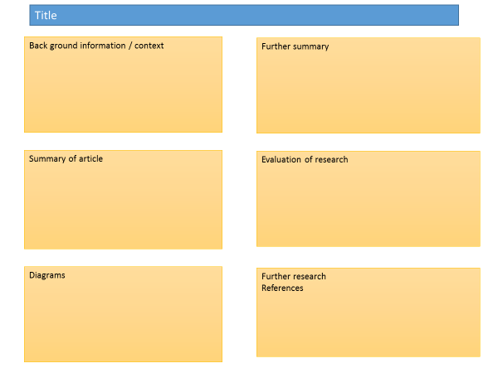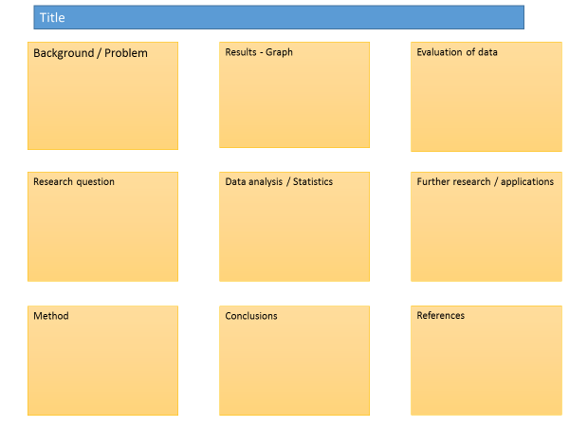It is easiest to create a poster in PowerPoint, however you need to add custom text boxes rather than using the standard templates.

Posters need to be eye catching, but readable from a distance. If you use PowerPoint, start with a 4:3 slide (for easier printing, it can then be printed on A3) and use a 14-16 pt font. The first box could be larger to draw people in. You can use a background image, but pick a simple one that is of high quality. Select ‘text box fill’ and select ‘change the transparency’ to maintain the contrast and partially show the picture.

You can experiment with different layouts and you should include images. Avoid a chaotic layout, posters are read from top left column downwards.

Remember to include the authors and references.

Finally, look at the examples given on the University of Texas website which also offers an evaluation of each [www.tinyurl.com/postereg](http://www.tinyurl.com/postereg)

**Independent skills – Level 5**

**Video summaries**

**A Level Chemistry – Atomic Structure**

**Cornell Notes**

At A level and University, you will make large amounts of notes, but those notes are only of use if you record them in a sensible way. One system for recording notes is known as the Cornell notes system. This method encourages you to select relevant information, rather than trying to write a transcript of everything said. More importantly, it forces you to spend a few minutes reviewing what you have written, which has been scientifically proven to aid learning and memory retention.

The ideal is to write everything on one page, but some students may prefer to type and others will to handwrite their notes. Whichever option you use, remember the aim is to summarise and condense the content with a focus on the objectives that you are trying to learn and understand.

**There are three main sections to the Cornell notes**

1. **Cue/ Objectives** – This can be done before or after the lecture. You may have been provided with the objectives or you may need to decide what they were or you may want to make the link to your learning if this is an additional task or lecture you are viewing, such as this video.
2. **Notes** – In this space you record concisely, simply the things you are LESS likely remember - **The NEW knowledge.**
3. **Summary** – The most important step that is carried out after the lecture or video. This helps to reinforce learning.

**Background**

The following series of videos link to your learning. The first is a summary of essential learning on electrochemistry produced by the excellent ‘Crash Course’. The second discusses the importance of large-scale batteries that are able to store renewable energy.

**Source article:**

**Video 1 – Just how small is an atom?**

**Ted talks:** <https://www.ted.com/talks/just_how_small_is_an_atom>

**Video 2 – Orbitals**

**CrashCourse YouTube channel:** <https://www.youtube.com/watch?v=cPDptc0wUYI&list=PLMFVtaoVOlACuq6-YIKvlUrbkPsqGbi9->

**Task:**

**You need to produce a set of Cornell notes for each of the videos given above.**

**Use the following objective to guide your note taking, this links to your learning.**

1. Discuss the relative size of atoms.
2. Discuss what molecules actually look like.

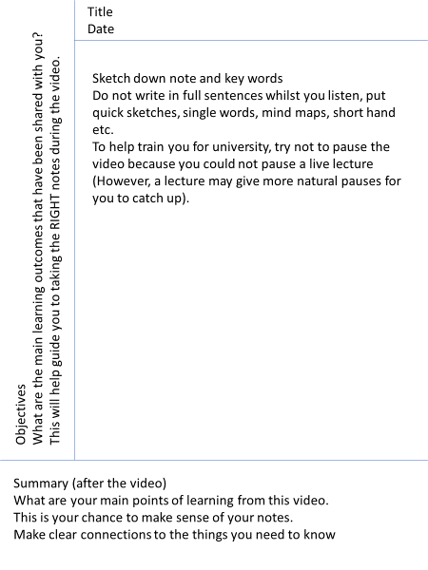

|  |  |
| --- | --- |
|  | **Title**  **Date** |
| **Objectives** |  |
| **Summary** | |

|  |  |
| --- | --- |
|  | **Title**  **Date** |
| **Objectives** |  |
| **Summary** | |