**Transition Pack for Level 3 Applied Science**

**What will you be taught?**

**Year 12**

Unit 1- Science Fundamentals –   
including chemical and biological reactions, chemical structures of elements and compounds, cell organisation and structures, carbon chemistry and the properties and uses of materials

Unit 6- Control of Hazards in the Laboratory –   
including the use of health and safety procedures to minimise hazards in a laboratory and being able to design a safe functioning laboratory.

**Year 13**

Unit 2- Laboratory Techniques –   
including the importance of health and safety, using aseptic techniques, separation of substances in a mixture, examining and recording features of biological samples, cations and anions in samples.

Unit 18- Microbiology –   
including being able to classify and identify microorganisms, to look at the use of microorganisms in agriculture, being able to use microbiology in food production and to understand the action of antimicrobials on microorganisms

Unit 21 Product Testing Techniques –   
including looking at the influence of regulatory bodies on development of consumer products, how product testing determines the development of consumer products, being able to use quantitative titration techniques on consumer products and being able to use extraction and separation techniques on consumer products

**How will it work?**

* 10 hours a fortnight
* 2 teachers – Mrs Newman and Mrs Ling
* 2 years
* 1 qualification!

You will be expected to complete an equal number of hours of revision and coursework outside of class time i.e. for every hour of class time you should spend an hour completing independent work.

**How will you be examined?**

* Unit 1 and Unit 2 have external exams.
* You will sit the Unit 1 examination at the end of Y12 (June).
* You will sit the Unit 2 examination in January of Y13.
* You will also complete a portfolio of coursework throughout the year –   
  no coursework, no qualification.

**What do you need to get?**

* Your own labcoat and goggles! (with your name on it!!)  
  The cheapest place you can buy these is actually Amazon!
* A ring-binder (it’s a good idea to have poly-pockets and subject dividers!)
* Lined paper

**Contact**

[a.petrie@chellaston.derby.sch.uk](mailto:a.petrie@chellaston.derby.sch.uk) (Head of Science)

j.weston@chellaston.derby.sch.uk

h.benn@chellaston.derby.sch.uk

**ACTIVITY ONE – BIOLOGY**

**Based on your GCSE knowledge from biology…**

Draw and label an animal and a plant cell including the functions of each organelle (cell component).

List 3 differences between prokaryotes and eukaryotes.



Explain the role of each of the following in the body:

* Muscle tissue-
* Bone tissue-
* Nerve cells-

Explain why it is important that muscle cells contain lots of mitochondria?

Where in the (eukaryotic) cell is DNA stored and why is it stored here?

What are carbohydrates made from and what is the name of the enzyme which breaks down carbohydrates?

Why is the shape of an enzyme important to its functioning?

Enzymes are sometimes referred to as biological catalysts. What is meant by the term “biological catalyst”?

What is meant by the term “optimum temperature” in relation to enzymes?

Why can viruses not be killed by antibiotics?

**ACTIVITY TWO - CHEMISTRY**

Part one – Atom and the Periodic Table:

1. Draw and label a carbon atom Carbon twelve in symbolic form. A capital C with the number 12 in superscript at the upper left and the number 6 in subscript at the lower left

|  |  |  |  |
| --- | --- | --- | --- |
| **Subatomic particle** | **Charge** | **Mass** | **Location** |
| Proton |  |  |  |
|  | 0 |  |  |
|  |  | Negligible |  |

1. Complete the table:
2. How are elements arranged on the Periodic Table?
3. What is the mass number of an element?
4. Calculate the relative atomic mass for calcium carbonate (CaCO3)  
   (Ar = Ca = 40, C = 12, O = 16)
5. What is an isotope?
6. What is an ion?
7. Why is potassium more reactive than sodium?

Part two – Atom and the Periodic Table:

Summarise the ‘Bonding and Structure’ topic into a mind-map.

**ACTIVITY THREE – HAZARDS**

**Looking ahead to next year…**

Find out what each of the following hazard symbols means.

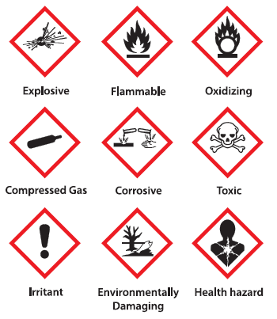

Find out what COSHH stands for and what it means.

Find out what RIDDOR stands for and what it means.

Identify some examples of…

…biological hazards.

…chemical hazards.

…physical hazards.

Research some ways in which the following might be controlled in a lab:

* Storage of radioactive materials
* Fumes from chemicals
* Waste disposal
* Storage of biological materials such as bacteria or bodily fluids

**Optional extras!**

**Book Recommendations**

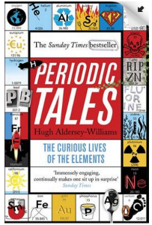**Periodic Tales: The Curious Lives of the Elements** (Paperback) Hugh Aldersey-Williams

ISBN-10: 0141041455

<http://bit.ly/pixlchembook1>

This book covers the chemical elements, where they come from and how they are used. There are loads of fascinating insights into uses for chemicals you would have never even thought about.

**The Science of Everyday Life: Why Teapots Dribble, Toast Burns and Light Bulbs Shine** (Hardback) Marty Jopson

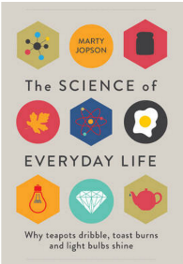ISBN-10: 1782434186

<http://bit.ly/pixlchembook2>

The title says it all really, lots of interesting stuff about the things around you home!

**Bad Science** (Paperback) Ben Goldacre

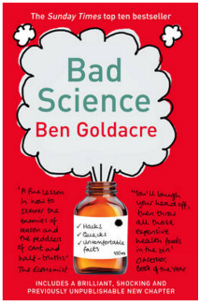ISBN-10: 000728487X

<http://bit.ly/pixlchembook3>

Here Ben Goldacre takes apart anyone who published bad / misleading or dodgy science – this book will make you think about everything the advertising industry tries to sell you by making it sound ‘sciency’.

**Videos to watch online**

**Rough science – the Open University – 34 episodes available**

Real scientists are ‘stranded’ on an island and are given scientific problems to solve using only what they can find on the island.

Great fun if you like to see how science is used in solving problems.

There are six series in total

<http://www.dailymotion.com/playlist/x2igjq_Rough-Science_rough-science-full-series/1#video=xxw6pr>

or

<https://www.youtube.com/watch?v=lUoDWAt259I>

**A thread of quicksilver – The Open University**

A brilliant history of the most mysterious of elements – mercury. This program shows you how a single substance led to empires and war, as well as showing you come of the cooler properties of mercury.

https://www.youtube.com/watch?v=t46lvTxHHTA

**10 weird and wonderful chemical reactions**

10 good demonstration reactions, can you work out the chemistry of …. any… of them?

<https://www.youtube.com/watch?v=0Bt6RPP2ANI>

**Chemistry in the Movies**

Dantes Peak 1997: Volcano disaster movie.

Use the link to look at the Science of acids and how this links to the movie. <http://www.open.edu/openlearn/science-maths-technology/science/chemistry/dantes-peak>

<http://www.flickclip.com/flicks/dantespeak1.html>

<http://www.flickclip.com/flicks/dantespeak5.html>

Fantastic 4 2005 &2015: Superhero movie

Michio Kaku explains the “real” science behind fantastic four <http://nerdist.com/michio-kaku-explains-the-real-science-behind-fantastic-four/>

<http://www.flickclip.com/flicks/fantastic4.html>

**Places to visit**

1. Go outdoors!

Have you actually spent any time observing the geology of the area you live in? What rocks or minerals are found in your area? Does your area have a history of extracting minerals? If so what were they, what were they used for, how did they obtain them? Are there any working or remains of mineral extraction industries?

1. Are there any chemical or chemistry based businesses in your area? A big ask, but one that could be really beneficial to you, write them a letter explaining that you are taking Applied Science and you want to see how chemistry/biology is used in industry and you would like to visit / have some work experience. You never know this could lead to great things!!!!
2. You could also try writing to / searching for your nearest university to see if they are running any summer schools for science – they are usually free and give you the opportunity to experience the laboratories in a university.
3. Science museums.

You could visit your nearest science museum. They often have special exhibitions that may be of interest to you.

<https://en.wikipedia.org/wiki/List_of_science_museums#United_Kingdom>

1. Somerset Earth Science Centre:

<http://www.earthsciencecentre.org.uk>

1. The UK Association for Science and Discovery Centres (ASDC)

This association brings together over 60 major science engagement organisations in the UK.

<http://sciencecentres.org.uk/centres/weblinks.php>

**Science on Social Media**



Science communication is essential in the modern world and all the big scientific companies, researchers and institutions have their own social media accounts. Here are some of our top tips to keep up to date with developing news or interesting stories:

Follow on Twitter:

Commander Chris Hadfield – former resident aboard the International Space Station @cmdrhadfield

Tiktaalik roseae – a 375 million year old fossil fish with its own Twitter account! @tiktaalikroseae

NASA’s Voyager 2 – a satellite launched nearly 40 years ago that is now travelling beyond our Solar System

@NSFVoyager2

Neil dGrasse Tyson – Director of the Hayden Planetarium in New York @neiltyson

Sci Curious – feed from writer and Bethany Brookshire tweeting about good, bad and weird neuroscience

@scicurious

The SETI Institute – The Search for Extra Terrestrial Intelligence, be the first to know what they find! @setiinstitute

Carl Zimmer – Science writer Carl blogs about the life sciences @carlzimmer

Phil Plait – tweets about astronomy and bad science @badastronomer

Virginia Hughes – science journalist and blogger for National Geographic, keep up to date with neuroscience, genetics and behaviour

@virginiahughes

Maryn McKenna – science journalist who writes about antibiotic resistance @marynmck