**[visit twinkl.com](https://www.twinkl.co.uk/resources/specialeducationalneeds-sen/specialeducationalneeds-sen-communication-and-interaction)**

**My New School Uniform**

**Social Story**

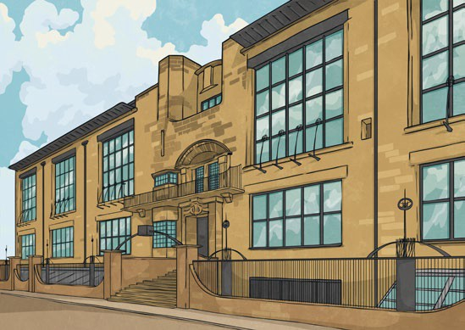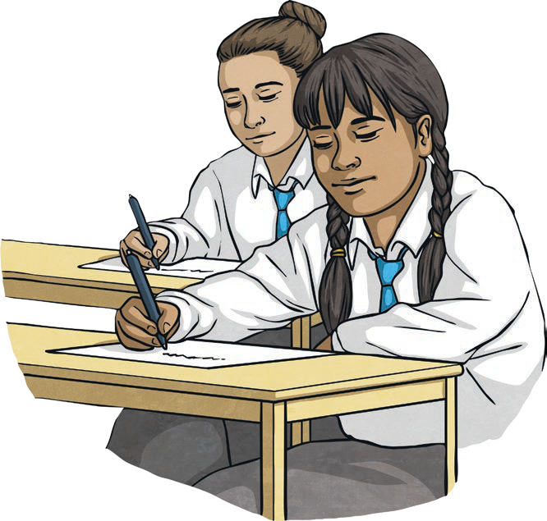

My school uniform will be the colours and

.

I will wear a white polo shirt,

trousers/skirt/shorts or a dress.

When it is cold, I might wear a jumper/cardigan or a fleece

jacket. I will need a bag to carry my school books and PE kit.

My uniform might feel a little different at first, but I will get

used to it. It is OK if it takes me a while to get used to the

feeling of the new clothes.

My name is .

When I need it, I can ask for help with my

uniform. Or I can ask student support for help.

When it is time to start school, I will be in a new school.

My new school is called .

Being in a new school will be lots of fun. I will learn new things and

make new friends.

I will be in form group.

I will wear special clothes - this is called a school uniform.

Wearing a new uniform every day will be exciting

and I will look

really smart!

A uniform is a set of clothes that I will need to wear for school every day. I will wear the same clothes as the other children in the school. This is OK.