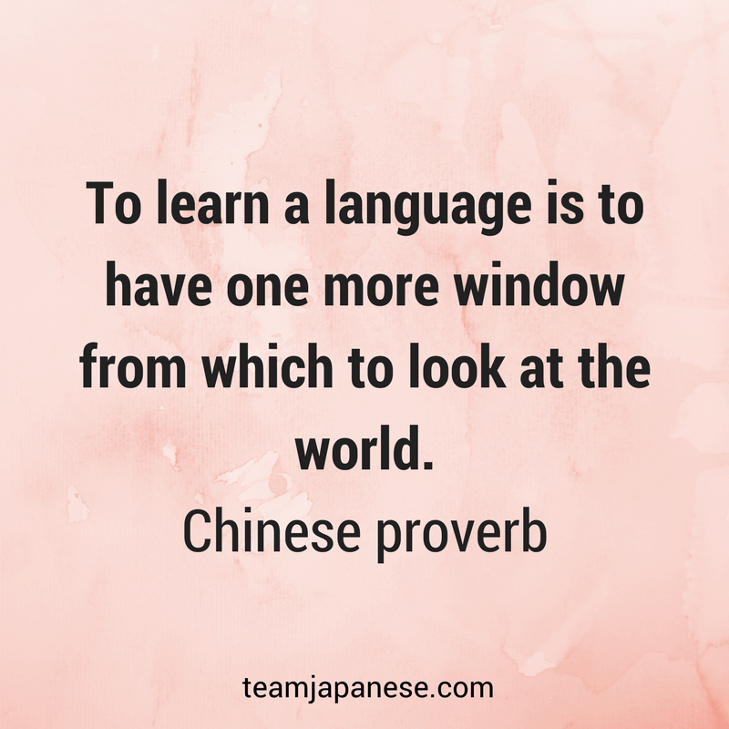

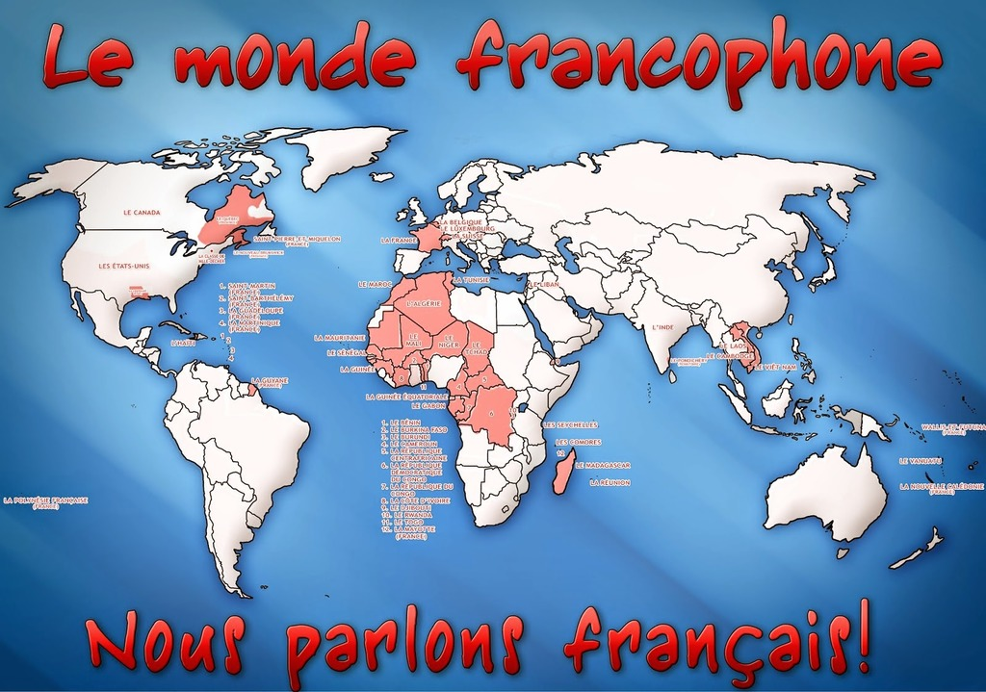

A Level French

We look forward to welcoming you to A level French in September but after your GCSE you will need to keep language-fit over the summer and you can also take some steps to make the return to French study easier and less stressful for yourself by doing some preparation work over the holidays to keep your hand in and so that you hit the ground running in September!

To that end we have put together a variety of activities to allow you to delve into the key thematic content and some focused grammar tasks to allow you to keep up your accuracy.

We follow the AQA French A Level:

<https://www.aqa.org.uk/subjects/languages/as-and-a-level/french-7652>

Here you will find detailed course content and assessment.

Use this booklet to support your transition from GCSE to A Level, but there is more you can do:

* Netflix and Amazon Prime have many French films and TV series you can watch.
* [www.tv5monde.com](http://www.tv5monde.com) has lots of topical articles for you to watch and listen to
* [www.newsinslowfrench.com](http://www.newsinslowfrench.com) is a great way to keep up with current affairs

In terms of commitment, study skills and organisation, we will be talking at greater depth about these issues in September, but, clearly, we expect you to be self-motivated, responsible learners who hit deadlines and stay on top of their language learning by good organisation and by doing a little but often to review notes and learn vocabulary.

Make a good job of the pack here and it will stand you in good stead for a relaxed and seamless start to 6th Form in September.

**On vous souhaite de très bonnes vacances! Bonne détente, mais…**

**bon travail!**

**Mme Castro et Mme Mackenzie-Scott**

**Course content:**

**YEAR 12**

**Aspects of French-speaking society; current trends**

**1 La famille en voie de changement**

**2 La cyber-société**

**3 Le rôle du bénévolat**

**Artistic culture in the French-speaking world**

**4 Une culture fière de son patrimoine**

**5 La musique francophone contemporaine**

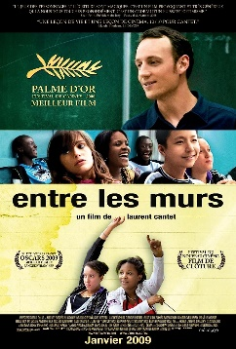**6 Cinéma - le septième art**

**Film – Entre les murs**

**YEAR 13**

**Aspects of French-speaking society; current trends**

**1 Les aspects positifs d’une société diverse**

**2 Quelle vie pour les marginalisés ?**

**3 Comment on traite les criminels**

**Aspects of political life in the French-speaking world**

**4 Les ados, les droit de vote et l’engagement politique**

**5 Manifestations, grèves – a qui le pouvoir ?**

**6 La politique et l’immigration**

**Novel – No et moi**

**Exams:**

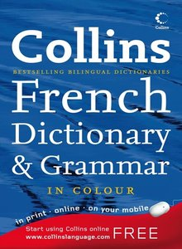**Resources:**

**What materials will I need?**

* a ring binder folder for all my AS resources
* a set of 8 dividers
* Lined A4 paper or other notebook for lessons
* Books from those listed below, we have included links to buy new, but many have options to buy used and are much more cost effective.

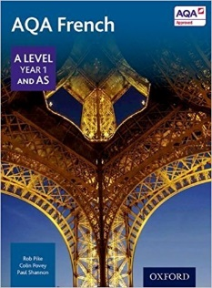**This is our textbook and it is always good to have your own copy:**

[**https://www.amazon.co.uk/Level-Year-French-studentBook/dp/0198366884/ref=pd_sim_14_3?_encoding=UTF8&psc=1&refRID=DNDGTAGGQ4ENSCBWC911**](https://www.amazon.co.uk/Level-Year-French-studentBook/dp/0198366884/ref=pd_sim_14_3?_encoding=UTF8&psc=1&refRID=DNDGTAGGQ4ENSCBWC911)

**The book covers all topics in Year 12 and Year 13 and provides essay phrases too:**

[**https://www.amazon.co.uk/Mot-Sixth-French-Vocabulary-level/dp/1510434801/ref=sr_1_1?crid=3W3TWRMB8KJ24&keywords=mot+%C3%A0+mot&qid=1687723920&s=books&sprefix=mot+%C3%A0+mot%2Cstripbooks%2C91&sr=1-1**](https://www.amazon.co.uk/Mot-Sixth-French-Vocabulary-level/dp/1510434801/ref=sr_1_1?crid=3W3TWRMB8KJ24&keywords=mot+%C3%A0+mot&qid=1687723920&s=books&sprefix=mot+%C3%A0+mot%2Cstripbooks%2C91&sr=1-1)

**A really handy grammar and translation practice workbook which will really take the stress out of grammar learning and practice: a must.**

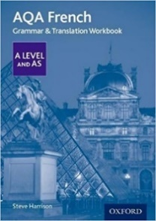[**https://www.amazon.co.uk/AQA-Level-French-Translation-Workbook/dp/0198415532/ref=sr_1_13?ie=UTF8&qid=1497525513&sr=8-13&keywords=french+grammar+book**](https://www.amazon.co.uk/AQA-Level-French-Translation-Workbook/dp/0198415532/ref=sr_1_13?ie=UTF8&qid=1497525513&sr=8-13&keywords=french+grammar+book)

**Theme activities:**

**Les films**

**Watch each of the trailers and write 40-60 word of what you think the film is about and what you think of it.**

**La Haine -** [**https://www.youtube.com/watch?v=FKwcXt3JIaU&t=13s**](https://www.youtube.com/watch?v=FKwcXt3JIaU&t=13s)



**___________________________________________________________________________________________________________________________________________________________________________________________________________________________________________________________________________________________________________________________________________________________________________________________________________________________________________________________________________________________________________________________________________________________________________________________________________________________**

**Les Intouchables -** [**https://www.youtube.com/watch?v=34WIbmXkewU**](https://www.youtube.com/watch?v=34WIbmXkewU)

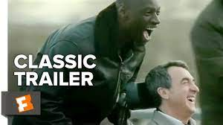

**___________________________________________________________________________________________________________________________________________________________________________________________________________________________________________________________________________________________________________________________________________________________________________________________________________________________________________________________________________________________________________________________________________________________________________________________________________________________**

**Au revoir les enfants -** [**https://www.youtube.com/watch?v=zXmvdKtMQcI**](https://www.youtube.com/watch?v=zXmvdKtMQcI)



**___________________________________________________________________________________________________________________________________________________________________________________________________________________________________________________________________________________________________________________________________________________________________________________________________________________________________________________________________________________________________________________________________________________________________________________________________________________________**

**Amélie -** [**https://www.youtube.com/watch?v=lrlQR_KH_nw**](https://www.youtube.com/watch?v=lrlQR_KH_nw)



**___________________________________________________________________________________________________________________________________________________________________________________________________________________________________________________________________________________________________________________________________________________________________________________________________________________________________________________________________________________________________________________________________________________________________________________________________________________________**

**La musique**

**Complete the table for the French-speaking musicians. Use** [**www.lyricstraining.com**](http://www.lyricstraining.com) **to get to know their music. Add in another musician of your choice:**

|  |  |  |  |
| --- | --- | --- | --- |
|  | **Pays d’origine** | **Age** | **3 chansons** |
| **Stromae**  **After seven years of hell, Stromae is back | Dazed** |  |  |  |
| **Angèle**  Belgian singer Angele on her experience of collaborating with Dua Lipa -  The Irish News |  |  |  |
| **Vianney**  Vianney décrit comme « très ami » avec Geoffroy Lejeune dans un article du  « Monde », le chanteur dément |  |  |  |
| **Maitre Gims**  **Maître Gims : quand les stars créent des tendances | Seecly** |  |  |  |
|  |  |  |  |

**Le patrimoine**

**Here are 6 celebrated UNESCO heritage sites. For each place write about 40 words to say where the heritage site is and describe it.**

**

**__________________________________________________________________________________________________________________________________________________________________________________________________________________________________________________________________________________________________________________________________________________________________________________________________________________**

**Cathédrale de Notre Dame**

**__________________________________________________________________________________________________________________________________________________________________________________________________________________________________________________________________________________________________________________________________________________________________________________________________________________**

**Djemila**

**__________________________________________________________________________________________________________________________________________________________________________________________________________________________________________________________________________________________________________________________________________________________________________________________________________________**

**L’arrondissement historique de vieux Québec**

**__________________________________________________________________________________________________________________________________________________________________________________________________________________________________________________________________________________________________________________________________________________________________________________________________________________**

**Grammar**

**Work through these to ensure your grammar knowledge is ready for A Level:**

**1. Gender and Number: Masculine, feminine, singular and plural:**

Marks out of /36

**Masculine or Feminine? (Highlight by circling M or F accordingly) Try it first without checking using a dictionary: can you see some patterns? [24 marks]**

M F ordinateur M F copain

M F appartement M F atmosphère

M F téléphone M F bâtiment

M F diffusion M F cadeau

M F voiture M F chanteuse

M F bleu M F peau

M F jumeau M F gâteau

M F beauté M F infirmier

M F préoccupation M F lycéen

M F liberté M F mariage

M F racisme M F électricien

M F mari M F silence

**Write the masculine form of the nouns. [12 marks]**

1. reine _____________ 2. cousine _____________

3. grand-père _____________ 4. vendeuse _____________

5. décoratrice _____________ 6. nièce ____________

7. fille _____________ 8. rédactrice _____________

9. Brésilienne _____________ 10. princesse _____________

11. copine _____________ 12. infirmière _____________

**2. Adjectives.**

Marks out of /26

**In each of these sentences:**

**- underline the adjective(s)**

**- highlight the noun they refer to**

**- state whether the noun is masculine or feminine, singular or plural. [12 marks]**

ex : Le choix d’un compagnon est **crucial.** **masc., singular**

1 Ma sœur est agaçante. ____________

2 Beaucoup d’enfants ont des relations tendues avec leurs parents. _____________

3 Le comportement de ma cousine est souvent agaçant. _____________

4 Pour les familles catholiques, le mariage a beaucoup d’importance. _____________

**Highlight the appropriate form of the adjective. [9 marks]**

a. Marc est égoïstes/égoïste, il a mangé le dernier/dernière gâteau !

b. Il a écrit un article facinant/fascinante pour un journal local / locale.

c. Mes enfants rêvent d’une vie familiale/familiaux sans problèmes. Ils veulent être indépendant / indépendants.

d. Elle a les cheveux longue / longs.

e. Damien a un look particulier/particulière, il a les cheveux verts /vertes

**Complete the list with the appropriate form of the adjective. [5 marks]**

• Un vieux livre une __________________ femme.

• Un bon vin une __________________ bière.

• Du pain frais des baguettes __________________.

• Un beau jour une __________________ journée.

• Un enfant actif des filles __________________.

3**. The present tense of regular verbs: You may need to research these endings and forms:**

Marks out of /33

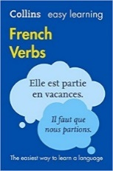

**Complete the following tables with the appropriate form of the present tense and highlight the ending. [18 marks]**

|  |  |  |  |
| --- | --- | --- | --- |
|  | **-er verbs** | **-ir verbs** | **-re verbs** |
|  | **regarder** | **finir** | **attendre** |
| **Je** |  |  |  |
| **Tu** |  |  |  |
| **Il/ elle/ on** |  |  |  |
| **Nous** |  |  |  |
| **Vous** |  |  |  |
| **Ils/ elles** |  |  |  |

**Fill in the gaps with the correct verb form [15 marks]**

01. Nous _________________ (investir) dans l’immobilier.

02. Je _________________ (descendre) l’escalier à toute vitesse.

03. Mes parents et moi _________________ (accepter) votre invitation.

04. Je_________________ (remplir) les verres des invités.

05. Nous _________________ (investir) dans l’immobilier.

06. Il _________________ (descendre) l’escalier à toute allure.

07. Mon frère et moi _________________ (accepter) votre invitation.

08. Elle _________________ (prétendre) être la plus intelligente.

09. Ils _________________ (habiter) en Normandie.

10. Il me _________________ (tendre) la main pour me dire bonjour.

11. Nous _________________ (visiter) le château de Fontainebleau.

12. Tu _________________ (répondre) aux questions du professeur

13. La presse anglaise _________________ (répandre) une rumeur inquiétante.

14. Vous _________________ (réfléchir) à leur proposition.

15. Ils_________________ (vendre) des fruits et légumes au marché.

**4. The present tense of irregular verbs. You will need to research these verbs to find out how they are irregular.**

Marks out of /90

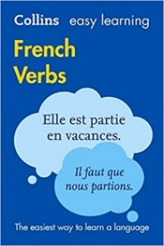**Complete the following tables with the appropriate form of the present tense. [72 marks]**

If you’re stuck you could go here: <http://conjugator.reverso.net/conjugation-french.html>

|  |  |  |  |
| --- | --- | --- | --- |
|  |  |  |  |
|  | prendre | être | tenir |
| **Je** |  |  |  |
| **Tu** |  |  |  |
| **Il/ elle/ on** |  |  |  |
| **Nous** |  |  |  |
| **Vous** |  |  |  |
| **Ils/ elles** |  |  |  |

|  |  |  |  |
| --- | --- | --- | --- |
|  |  |  |  |
|  | avoir | pouvoir | faire |
| **Je** |  |  |  |
| **Tu** |  |  |  |
| **Il/ elle/ on** |  |  |  |
| **Nous** |  |  |  |
| **Vous** |  |  |  |
| **Ils/ elles** |  |  |  |

|  |  |  |  |
| --- | --- | --- | --- |
|  |  |  |  |
|  | aller | boire | partir |
| **Je** |  |  |  |
| **Tu** |  |  |  |
| **Il/ elle/ on** |  |  |  |
| **Nous** |  |  |  |
| **Vous** |  |  |  |
| **Ils/ elles** |  |  |  |

|  |  |  |  |
| --- | --- | --- | --- |
|  |  |  |  |
|  | vouloir | craindre | connaître |
| **Je** |  |  |  |
| **Tu** |  |  |  |
| **Il/ elle/ on** |  |  |  |
| **Nous** |  |  |  |
| **Vous** |  |  |  |
| **Ils/ elles** |  |  |  |

**Fill in the gaps with the correct verb form in the present tense. [18 marks]**

• J’ (1)_________________ (avoir) des copains qui (2) _________________ (boire) et qui (3)_________________ (fumer). Ils (4)_________________ (vouloir) arrêter, mais ils ne (5) _________________ (pouvoir) pas.

• Je (6)_________________ (vouloir) être heureuse et voyager.

• Vous (7)_________________ (avoir) de la chance, vous (8)_________________ (voyager) beaucoup.

• Quand je (9)_________________ (aller) chez des copains, on (10)_________________ (jouer) à la console. Nous (11)_________________ (avoir) des blogs sur lesquels on (12)_________________ (partager) nos photos.

• Mon frère (13)_________________ (vendre) beaucoup de choses sur internet.

• Mon frère et ma sœur (14) ________________ (porter) souvent des vêtements bizarres.

• On (15)_________________ (apprendre) quelque chose de nouveau à chaque leçon.

• Ils (16) _________________ (applaudir) toujours mes efforts.

• Tes parents (17)_________________ (connaître) très bien les miens.

• Que (18)_________________ -vous? (craindre)

Still stuck? <http://conjugator.reverso.net/conjugation-french.html>

**5. The perfect tense with avoir.** [**https://www.youtube.com/watch?v=MnUWNIN3zss**](https://www.youtube.com/watch?v=MnUWNIN3zss)

Marks out of /50

**6. The perfect tense with être.** [**https://www.youtube.com/watch?v=z2IrJ0DB0Xg**](https://www.youtube.com/watch?v=z2IrJ0DB0Xg)

**Fill in the gaps with the correct form of the auxiliary: which one to use?**  **(10 marks)**

01. j’ __________ étudié 02. vous __________ fini

03. tu __________ fait 04. nous __________ lu

05. elles __________ parties 06. elles __________ dit

07. on __________ fermé 08. tu __________ tombé

09. il __________ aimé 10. ils __________ déménagé

**Fill in the gaps with the correct form of the past participle**. **(15 marks)**

11. boire ______________ 12. dire ______________

13. faire ______________ 14. lire ______________

15. organiser ______________ 16. penser ______________

17. prendre ______________ 18. recevoir ______________

19. savoir ______________ 20. vendre ______________

21. venir ______________ 22. vouloir ______________

23. devenir ______________ 24. mourir ______________

25. descendre _______________

**Underline the verbs in the perfect tense. Write their infinitive forms: (5 marks)**

Ex : Vous avez répondu au téléphone. répondre

25. Ils ont cueilli des fleurs. _________________________

26. Elle a fait un stage en entreprise. _________________________

27. Ils ont pris le bus. _________________________

28. Tout le monde a compris cet exercice. _________________________

29. Mon stage m’a plu. _________________________

30. Il n’a pas voulu me serrer la main. _________________________

**Write the correct perfect tense form of the verbs in bracket. Be careful: one of them is irregular. (6 Marks)**

31. J' _________________________ (passer) une semaine en Dordogne.

32. Elle _________________________ (sortir) avec mon cousin.

33. Nous _________________________ (arriver) très tard.

34. Mes parents _________________________ (lever) de bonne heure.

35. Nous ________________________ (regarder) un bon film.

36. Elle ________________________ (recevoir) des commentaires positifs.

**Circle the correct past participle. (7 Marks)**

37. Pierre est **allé / allée / allés / allées** en France.

38. La voiture de mes parents est **tombé / tombée / tombés** en panne.

39. Je suis **devenu / devenue / devenus / devenues** toute rouge car je suis restée trop longtemps au soleil.

40. L’avion est **parti / partie / partis** du terminal numéro un.

41. Elliot et Léa sont **tombé / tombés / tombée** amoureux pendant les vacances.

42. Ils sont **revenu / revenus / revenues** dans leur chambre d’hôtel.

43. Les trains ne sont pas **arrivé / arrivés / arrivé** à l’heure.

**Translate these sentences into French, using the verb suggested in brackets. (7 Marks)**

44. The girls got washed. (se laver)

_______________________________________________________________

45. She took some good resolutions (prendre)

_____________________________________________de bonnes resolutions.

46. She went to bed late. (se coucher)

___________________________________________________________tard.

47. I have eaten too much! (manger)

_______________________________________________________________

48. She ran 10 kilometres. (courir)

________________________________________________________10 kilomètres.

49. We laughed together. (rire)

___________________________________________________________ensemble.

50. They argued. (se disputer)

**7. The near future.**

Marks out of /48

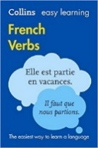**8. The future tense. Research and/ or revision of endings needed**

**9. The future – irregular verbs. Research and revision needed.**

[**http://conjugator.reverso.net/conjugation-french.html**](http://conjugator.reverso.net/conjugation-french.html)

**Complete the sentences with the appropriate form of the verb ‘aller’ (6 Marks)**

01. Je ___________________ partir à Pâques.

02. Mon copain ___________________ acheter nos billets d’avion.

03. Est-ce que tu ___________________ passer la journée en ville ?

04. Vous ___________________beaucoup vous amuser.

05. Ta grand-mère ___________________ faire une croisière sur le Nil.

06. Cet été, je ne ___________________ pas aller en Turquie.

**Rewrite the following sentences in the near future. (4 Marks)**

07. Je visiterai Londres. ________________________________________________________

08. Tu partiras assez tôt. ______________________________________________________

09. Vous passerez du temps en ville. ___________________________________________________________________________

10. Nous nous amuserons ensemble. ___________________________________________________________________________

**Fill the gap with the future tense of the verbs in brackets. (4 Marks)**

11. Mes amis _____________________________ (divorcer) sans doute.

12. Nous _____________________________ (acheter) son nouveau CD.

13. Laïla _____________________________ (se marier) bientôt.

14. Est-ce que tu _____________________________ (essayer)

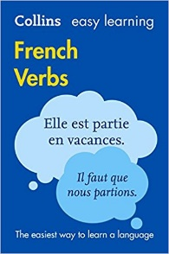**Fill the grid with the future tense of the verbs shown in the infinitive form. These are the common irregulars which you will need to research and find! (16 Marks)**

|  |  |  |  |
| --- | --- | --- | --- |
| Example | To go | aller | **J’irai** |
| 15 | To catch sight | apercevoir |  |
| 16 | To have | avoir |  |
| 17 | To run | courir |  |
| 18 | To become | devenir |  |
| 19 | To have to | devoir |  |
| 20 | To send | envoyer |  |
| 21 | To be | être |  |
| 22 | To do | faire |  |
| 23 | To be necessary | falloir |  |
| 24 | To die | mourir |  |
| 25 | To rain | pleuvoir |  |
| 26 | To receive | recevoir |  |
| 27 | To come back | revenir |  |
| 28 | To know | savoir |  |
| 29 | To come | venir |  |
| 30 | To see | voir |  |

**Match the English and French verbs. (14 Marks)**

31. I will buy A. elle achètera

32. I shall see B. elle pourra

33. I will have C. elles seront

34. we will go D. il y aura

35. they will come E. ils essaieront

36. they will be F. ils iront

37. you will do G. ils viendront

38. they will go H. j’achèterai

39. there will be I. j’aurai

40. they will try J. je verrai

41. you will be K. nous serons

42. she will buy L. on ira

43. we will be M. tu seras

44. she will be able to N. vous ferez

**Make all the elements of the sentence singular. (2 Marks)**

45. Vous prendrez des cours de natation. __________________________________________________________________

46. Nous achèterons de nouvelles raquettes. __________________________________________________________________

**Make all the elements of the sentence plural. (2 Marks)**

47. J’apprendrai une nouvelle activité. __________________________________________________________________

48. Tu essaieras un sport moins violent. ____________________________________________

**10. The imperfect tense. You will need to research and/ or revise the formation and the endings for this tense: Remember you need to know the ‘nous’ form of the present tense to form it correctly!**

Marks out of /20

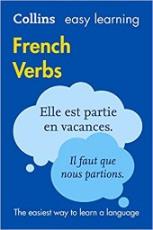

**Fill the gap with the imperfect tense of the verbs in brackets. (20 Marks)**

01. Il (croire) _______________________ que tu ne voulais pas venir.

02. Je (être) _______________________ à la montagne.

03. Elle (penser) _______________________ à ses prochaines vacances.

04. Ils (espérer) _______________________ un miracle.

05. Elle (avoir) _______________________ très faim.

06. Je (savoir) _______________________ qu’il avait raison.

07. Nous (être) _______________________ réalistes.

08. Vous (paraître) _______________________ sceptique.

09. L’exposition (être) _______________________ fascinante.

10. Il (faire) _______________________ un temps glacial.

11. Nous (suivre) _______________________ des cours de danse tous les mardis.

12. Je (faire) _______________________ de la natation tous les jours.

13. La vie (être) _______________________ plus facile.

14. Nous (faire) _______________________ la grasse matinée tous les dimanches.

15. À cette époque, ils (habiter) _______________________ en banlieue.

16. Nous (boire) _______________________ du café.

17. Autrefois, ils (assister) _______________________ à tous les concerts.

18. Dans son enfance, elle (faire) _______________________ de l’équitation.

19. Dans le passé, vous (se voir) _______________________ plus souvent.

20. Elle (travailler) _______________________ chez Guerlain.

<http://conjugator.reverso.net/conjugation-french.html>

**11. The perfect vs the imperfect: when to use which tense: how to decide? Research and revise!**

Marks out of /11

**Fill in the gaps with the appropriate form of the verb – Perfect or imperfect? (11 Marks)**

01. Je (aller) _______________________chez le dentiste hier.

02. Quand il (être) _____________________ adolescent, il (jouer)__________ au football.

03. À cette époque-là, ils (tenir) _______________________ une brasserie place d’Italie.

04. Ils (se promener) _______________________ dans les Alpes le week-end passé.

05. Nous (dîner) _______________________ dans ce restaurant tous les samedis.

06. Si on (prendre) _______________________ un café?

07. Tu (avoir) _______________________ l’air fatigué.

08. Chaque jour, il (écrire) _______________________ une lettre à son amie.

09. Je (regarder) _______________________ un film quand elle (arriver) ______________________

Here are some websites which may be useful for revising and practising grammar:

• [www.languagesonline.org.uk](http://www.languagesonline.org.uk) general site with an A level section (very good grammar)

• <http://french.about.com> a really good site for clear grammar explanations

• [www.verb2verbe.com](http://www.verb2verbe.com) great online conjugation tool – you can test yourself too

• [www.bbc.co.uk/languages](http://www.bbc.co.uk/languages) interesting site, lots of revision, great French slang section

• [www.lepointdufle.net](http://www.lepointdufle.net) comprehensive search engine for French grammar

• <https://www.lawlessfrench.com/> another good site for interactive grammar activities