|Write a definition for the following terms and add two example materials.

Thermoplastic

Thermosetting plastic

Elastomer

Ferrous metal

Non-Ferrous metal

Alloy

Hardwood

Softwood

Manufactured board

Analyse the two products below and compare them against each other. Write as much detail as possible.

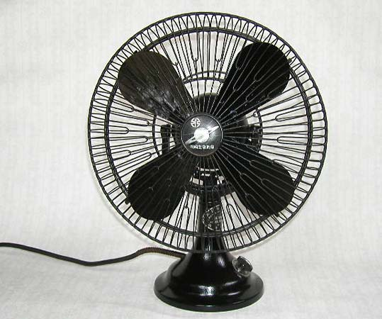 

1. Learn to draw these diagrams from memory. This will be tested when you come back in Year 12.

2. Use the internet to research how the process of blow moulding works.

3. On 1 A4 sheet, draw out the diagrams neatly an explain the process. Try to add your own detail to the notes, rather than just copy what has been given. This will help your understanding.

4. Add images of products which have been made using blow moulding from the internet. What materials are suitable?

Suggest advantages and disadvantages to using this process. All diagrams and the descriptions should be hand drawn/written. This theory will be needed on your course and may appear in your exam.

Blow Moulding

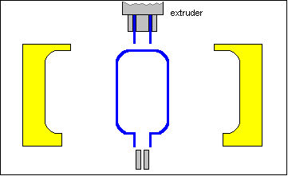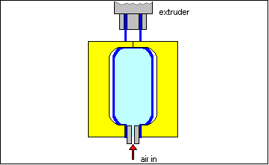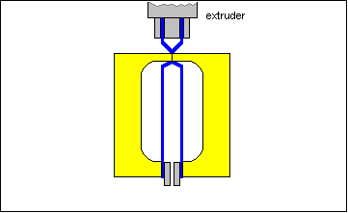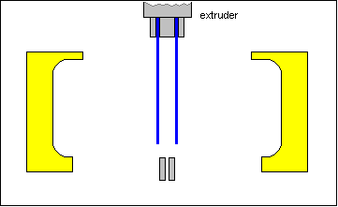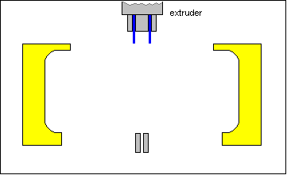

Cold mould

Stage 4 -Hot air is blown in to inflate the parison to the shape of the mould.

Stage 3 -The mould is closed. Base is trapped together.

Stage 2 -Parison is lowered down to the air inlet.

Stage 1 - Granules heated until molten.

A tube of plastic (parison) is extruded downwards.

Stage 5 –The mould is opened and the product is taken out. Flash is removed.

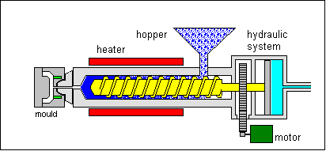

split mould

runner/sprue

1. Learn to draw this diagram from memory. This will be tested when you come back in Year 12.

2. Use the internet to research how the process of injection moulding occurs. This is a good link to get you started. <https://www.youtube.com/watch?v=RMjtmsr3CqA>

3. On 2 A4 sheets, explain this process using the diagram to help. Add images of products which have been made using injection moulding from the internet. Suggest advantages and disadvantages to using this process. All diagrams and the descriptions should be hand drawn/written. This theory will be needed on your course and may appear in your exam.

Injection Moulding

gears

ejector pins

cooling water

granules/pellets

Archimedean screw