 COMPUTER SCIENCE

**Summer Work:**

Over the holiday, download and install visual studio - students can download this for free as a community edition

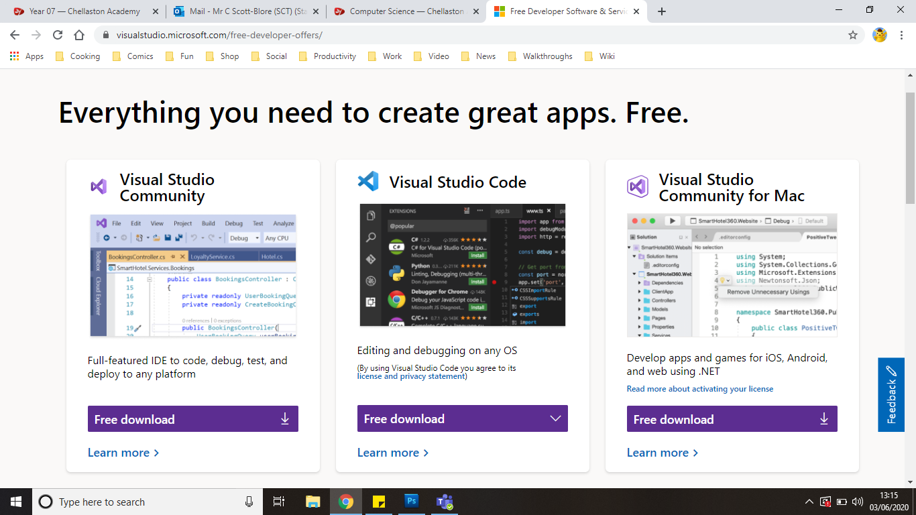

…and begin practice of C# using the following website:

<http://csharp.net-tutorials.com/basics/introduction/>

Complete all of the tutorials under the three headers circled in the image below. Save your programs separately as proof of completion will be required at the start of the course.

Please develop and bring with you one piece of code that covers as many of your new skills so far.

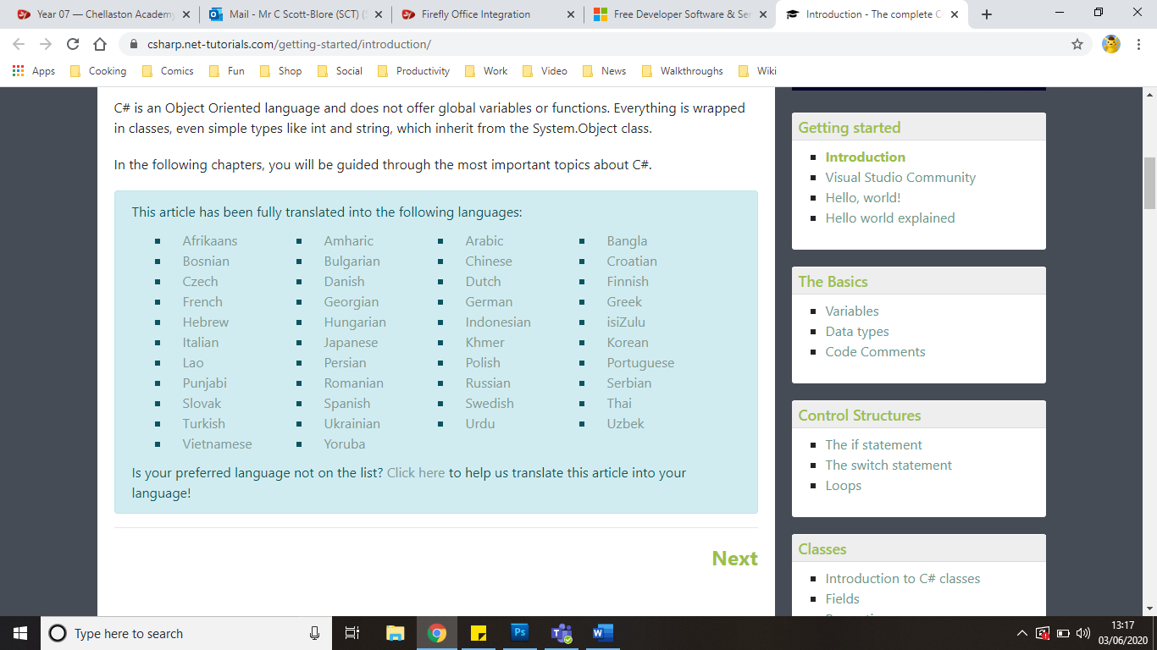

(if you cannot manage to download visual studio and/or cannot complete the tutorials and need help, email me at [i.cox@chellaston.derby.sch.uk](mailto:i.cox@chellaston.derby.sch.uk) asap (not a week before school starts!)) I hope to see you all in September.