A level Music
Summer Transition Booklet
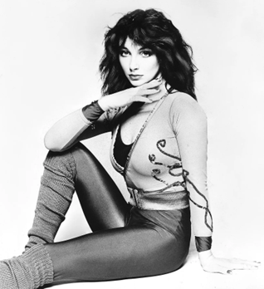
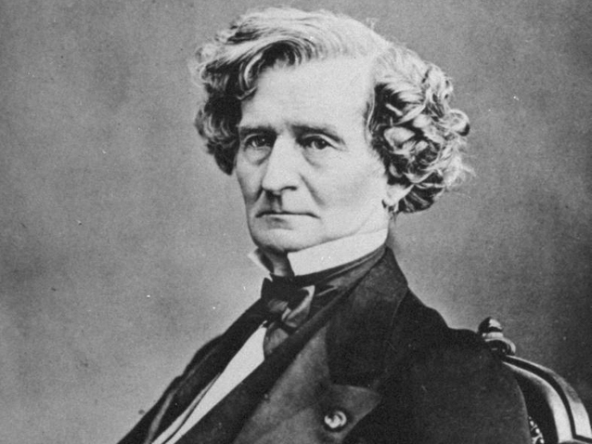
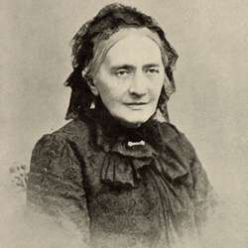
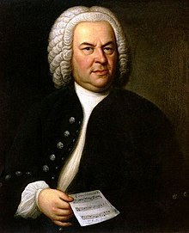
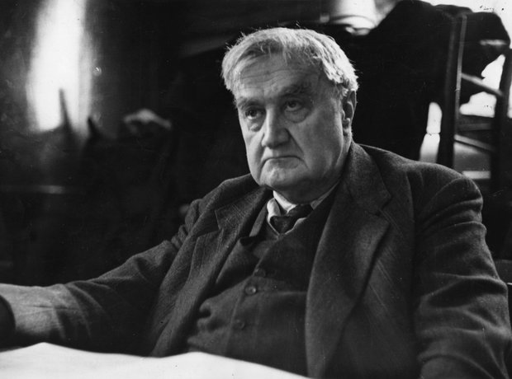
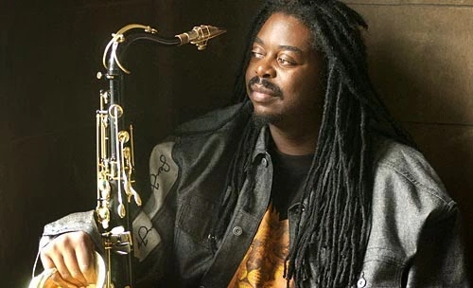
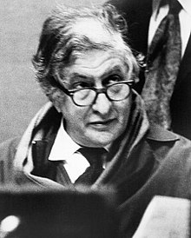
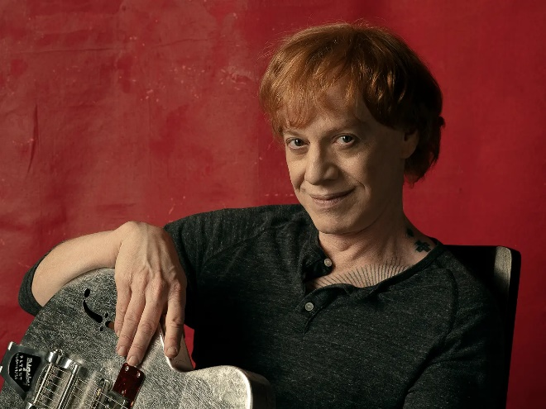


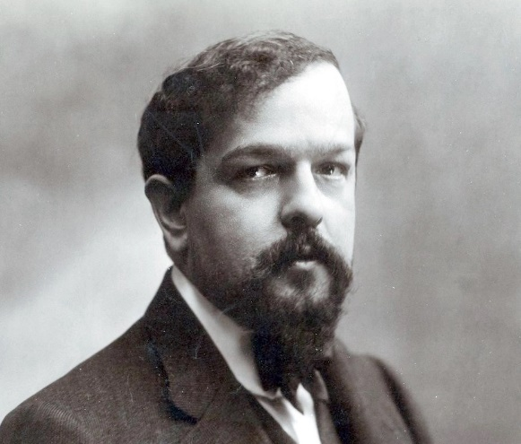


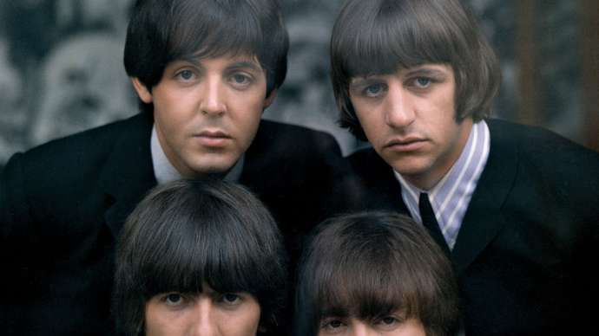
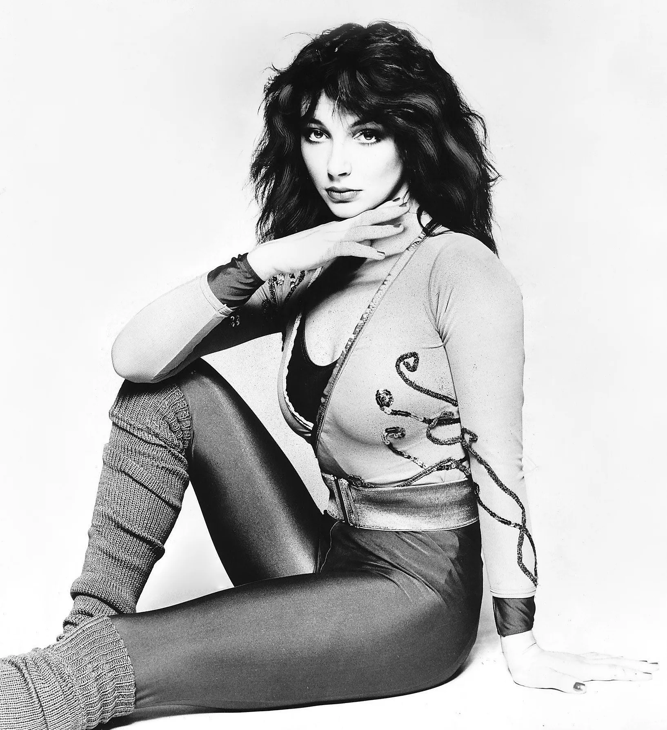
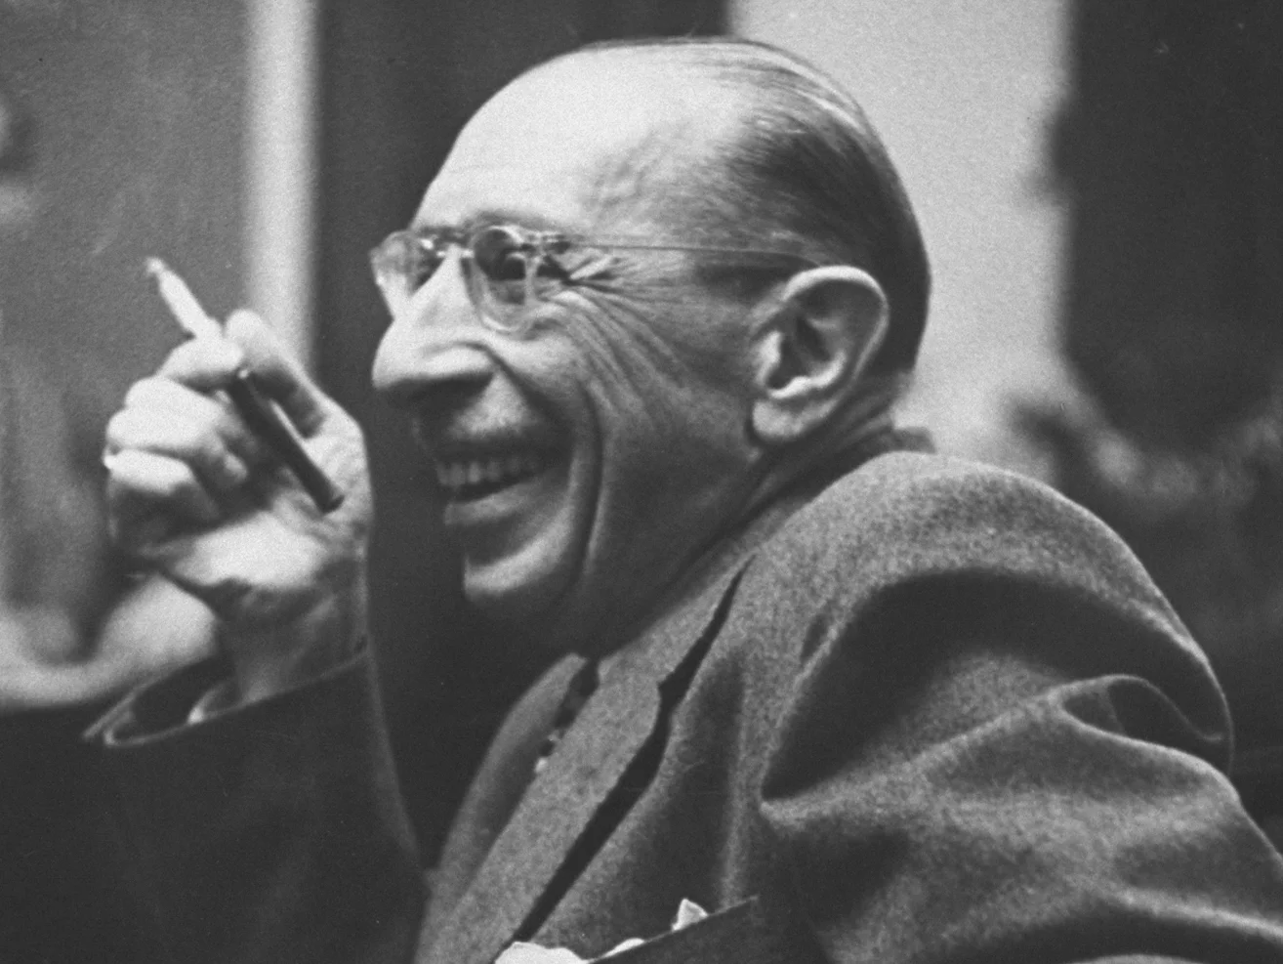
Component One: Performing

Component 1 (30%) will be a performance recital of one or more pieces, playing or singing a solo, in an ensemble, improvising, or realising music using music technology. The total performance time across all pieces must be a minimum of eight minutes. Recital will be recorded after 1st March in year 13.

Grade 6 (or equivalent) is considered ‘standard’, therefore lower grades are considered ‘less difficult’ and grades 7/8 are considered more difficult.

Transition tasks:
- Start to think about what pieces you already play which are at the top of your ability – which pieces could you include as part of your performance portfolio?
- Speak to your instrumental teacher and decide on some future pieces you can practice over the two years – try your best to ensure that the pieces are around grade 6 minimum so that you don’t lose any marks for your recital.
- Create a practice diary – it is suggested that you practice your recital pieces for a minimum of 3 hours a week in order to get them to a high standard.
- Listen to these pieces played professionally – use spotify/amazon/youtube to listen to different versions of your chosen pieces and see how dynamics/phrasing are used to shape the performances.

Component Two: Composing

Composition 1 – Either to a Pearson Brief or a free composition. Minimum length of four minutes.

Composition 2 – To a Pearson brief assessing compositional techniques. Minimum length of 1 minute.
Choose from one of the following:
- Bach chorale
- Two-part counterpoint
- Arrangement
- Remix

Transition tasks:
- You can start composition 1 at any time, and we would strongly advise starting over the summer.
- If you have your own laptops with your own music software then that is great, but if not you can start to get some ideas either on MUSESCORE (for notation) or garageband (for a Cubase-style format), or even just acoustically.
- Try and decide on a genre and do lots of wider listening around your chosen style – what musical features does this style often include?
- We will cover composition 2 within lessons but you can still research what these are and the main characteristics found in each one. We would advise having a go at each of these techniques in your own time.

Component Three: Appraising
Here is the list of set works covered:
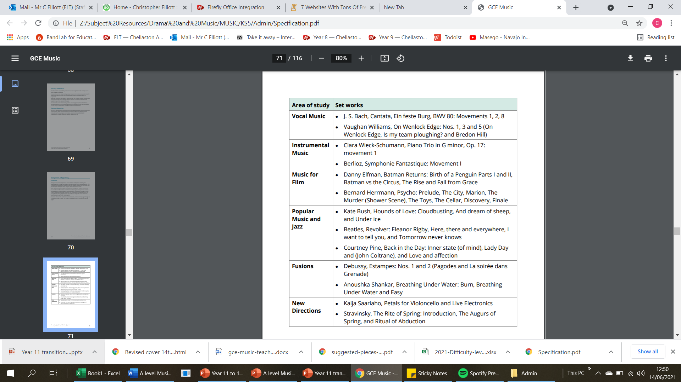

Transition tasks:

- Listen to each set work listed as much as possible – create a playlist, and get to know the characteristics of each piece.

- For each set work, do a ‘first impression’ analysis covering the following:
- Any context you may already know
- Instruments used
- Melodic/harmonic features you can identify
- Texture/rhythm/tempo/metre features
- Can you work out the general structure?
- Anything particularly unique about the music?

- For each set work, listen to two other pieces from the same composer/artist. How does this music compare to the set works? What is similar/different?

- For each set work, research one other composer/artist who wrote/writes similar music. How does their music compare to the set works? What is similar/different?

