**PHYSICAL EDUCATION**

**OCR A LEVEL PE**

**CHELLASTON ACADEMY PHYSICAL EDUCATION**

**A LEVEL PE – AN INTRODUCTION**

You have chosen to spend the next two years studying A Level Physical Education. This is a tremendous opportunity to study a fascinating subject in a faculty that is passionate about sharing their subject with you. But do not be lulled into thinking that you have chosen an easy option and a good grade is a formality. We are a very supportive department but your attitude towards learning is what matters most.

You are to study a subject, which will provide the opportunity to develop a range of techniques, personal skills, and attributes to enter higher education or employment in sport and active leisure. The units cover a wide scope of interests, this allows everyone to find an area of strength. It also means that you will find some areas more demanding. If you work hard in ALL units, will you succeed.

It is assessed through three external examinations and two NEA coursework components. The NEA is comprised of a practical unit where you will be assessed in ONE sport (that is included in the OCR specification) and a verbal response where you will need to analyse and evaluate a performer in a sport of your choice (again from the specification list). Therefore, you must be prepared to put in a good deal of your own time to improve your understanding through reading class notes and completing all homework set.

Be aware that you will be required to work very hard and that laziness or performance below your best will not be tolerated. All work will be handed in on time. When homework is set, it should be looked at the same day so if there is a problem, you can see your teacher the next day to ensure that you complete the homework on time, and do not make the excuse that you did not understand what you had to do.

Similarly, if you are absent for any reason, it is your responsibility to seek out your teacher to find out what you have missed in the lesson and to get any homework so it can be completed by the due date.

You will find that all PE staff always demand your best efforts, and it is this graft that brings results. The PE staff will give their best efforts and commitment to your study with additional sessions/resources, but you must be prepared to approach them for such help.

Remember that this is A Level and you are:

1. Here by choice
2. Intelligent – you have done well to gain the necessary access grades
3. Expected to work very hard

You will expect to be treated like an adult, and it is therefore up to you to accept certain responsibilities, which include having the good sense and confidence to ask a teacher for help if you do not understand something. It is our job to help you and we will be happy to go over and over a topic with you if necessary. Do not sit and suffer in silence, ask the question – it is likely that others will be feeling the same way.

While in school you will have non-contact time, but you should not regard this as ‘free time’. You will find that if you do not use this time wisely you will not maintain the necessary standard of work to achieve a high grade. You should use this non-contact time to do the following:

1. Read over work done in class
2. Read around areas covered in class
3. Complete homework set in class

You will not get a top grade purely on lesson notes – use the textbooks and the resources available in the PE department and Firefly pages. We really want you to do well. Work hard, enjoy yourself and never be afraid to ask for help.

We strongly advise that you purchase the course textbooks. We will be starting with content from book 1.

* OCR A Level PE Book 1

J Honeybourne & S Powell

Publish Date 24/06/16

ISBN = 9781471851735

* OCR A Level PE Book 2

J Honeybourne & S Powell

Publish Date 26/08/16

ISBN = 9781471851742

If you ever have a question, please e-mail:

Miss E. Davies ([e.davies@chellaston.derby.sch.uk](mailto:e.davies@chellaston.derby.sch.uk))

**A LEVEL PHYSICAL EDUCATION (OCR H555)**

**UNITS AND HOW THEY ARE ASSESSED**

**TRANSITION WORK**

**COMPONENT 01 – Physiological Factors Affecting Performance**

This involves **THREE** areas of study, makes up 4 out of 10 lessons each fortnight and is assessed by a **2 HOUR EXAMINATION** paper**.** It is worth 90 marks **(30%** of your total A Level)

1. **Applied Anatomy & Physiology**

**Task:**

<http://www.anatomyarcade.com/games/PAM/PAM.html>

Click on the link above and beat the teacher to Poke Russel the Muscle Man. Take a screen shot / photo of your overall score and add it to this booklet as evidence.

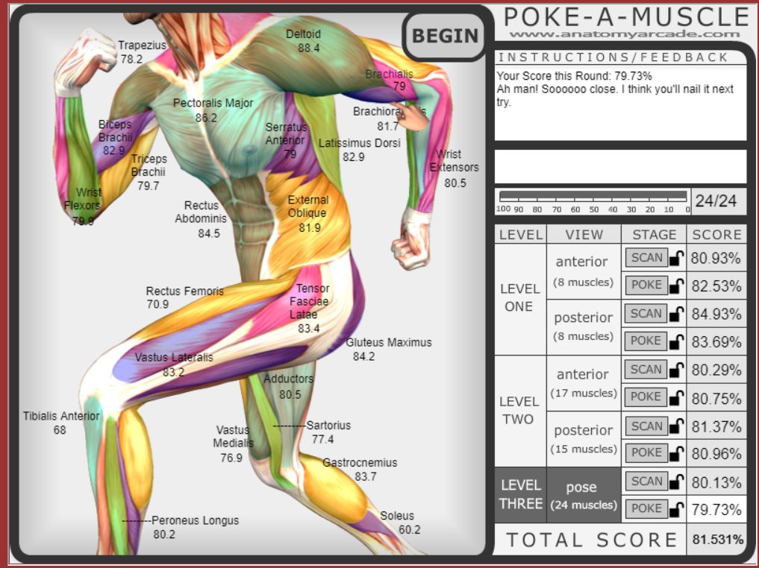

**Task:**

Complete the Joints, muscles and muscle movement worksheets on the firefly page.

1. **Exercise Physiology**

**Task:**

Complete the Diet and Nutrition worksheets on the firefly page.

1. **Biomechanics**

**Task:**

Complete the Levers worksheet on the firefly page.

**COMPONENT 02 – Psychological Factors Affecting Performance**

This involves **TWO** areas of study, makes up 2 out of 10 lessons each fortnight and is assessed by a **1 HOUR EXAMINATION** paper. It is worth 60 marks **(20%** of your total A Level).

1. **Skill Acquisition**

**Task:**

Complete the Classification of Skills worksheet on the firefly page.

1. **Sports Psychology**

**Task:**

Research and answer the following questions.

1. Explain the difference between intrinsic motivation and extrinsic motivation.
2. Give two examples of intrinsic motivation and two examples of extrinsic motivation.
3. Explain tangible and intangible rewards.
4. Evaluate intrinsic motivation.
5. Evaluate extrinsic motivation.
6. Define arousal.
7. Explain the inverted U theory.
8. Identify the four factors that can affect optimum arousal level.
9. Explain the catastrophe theory, using a practical example.
10. What is the difference between cognitive anxiety and somatic anxiety?

**COMPONENT 03 – Socio-Cultural Issues in Physical Activity & Sport**

This involves **TWO** areas of study, makes up 2 out of 10 lessons each fortnight and is assessed by a **1 HOUR EXAMINATION** paper. It is worth 60 marks **(20%** of your total A Level).

1. **Sport & Society**

**Task:**

Follow the colour coded social factors on the ‘Sport in Twentieth Century Britain’ worksheet and create a timeline for each: Class, time & money / Amateurism & Professionalism / Law & Order / Education / Transport / Gender / Olympic Games / General Interest

1. **Contemporary Issues in Physical Activity & Sport**

**Task:**

Complete Routes to Sporting Excellence worksheet on the firefly page.

**COMPONENT 04 – Performance in Physical Education**

This involves **TWO** areas of study

1. **Performance or Coaching in ONE ACTIVITY**
2. **Evaluation & Analysis of Performance for Improvement (EAPI) – Verbal Assessment**

It is worth 60 marks **(30%** of your total A Level)

GUIDELINES

* You will have to select your strongest activity from the list below
* If you select to do coaching you MUST be active at a high level in order to achieve a high mark

Activities Available

Association Football (NOT 5-aside or Futsal)

Amateur Boxing

Athletics

Badminton

Basketball

Camogie

Canoeing

Cricket

Cycling (Track or Road)

Dance

Diving (Platform)

Equestrian

Gaelic Football

Golf

Gymnastics

Handball

Hockey (Field)

Hurling

Kayaking

Lacrosse

Netball

Rock Climbing

Rowing

Rugby League

Rugby Union

Sculling

Skiing

Snowboarding

Squash

Swimming

Table Tennis

Tennis

Trampolining

Volleyball

In order to make a sensible choice you need to visit the OCR website and look at the criteria for the activities you are considering.

To make a sensible choice you need to print off and read thoroughly the criteria for your activity. You must be regularly competing in the activity of your choice

TASK 1 - Find the criteria:

OCR Home Page > Subject > Physical Education > AS/A level GCE > Physical Education H155, H555 (2016) > Scroll Down to Assessment Materials > Guide to Non-Exam Assessment

**TASK 2 – Print the criteria/Read the criteria:**

Now find your activity, print off the criteria, read them thoroughly, and file them in your PE folder. We will be asking to see these at the start of the academic year. Your PE folder should be a lever arch with dividers for each topic. All your work should be kept in order and you will have regular inspections.

**Make sure you have completed all of your work and have placed it in your file for PE. This should be brought with you on your first day at sixth form.**