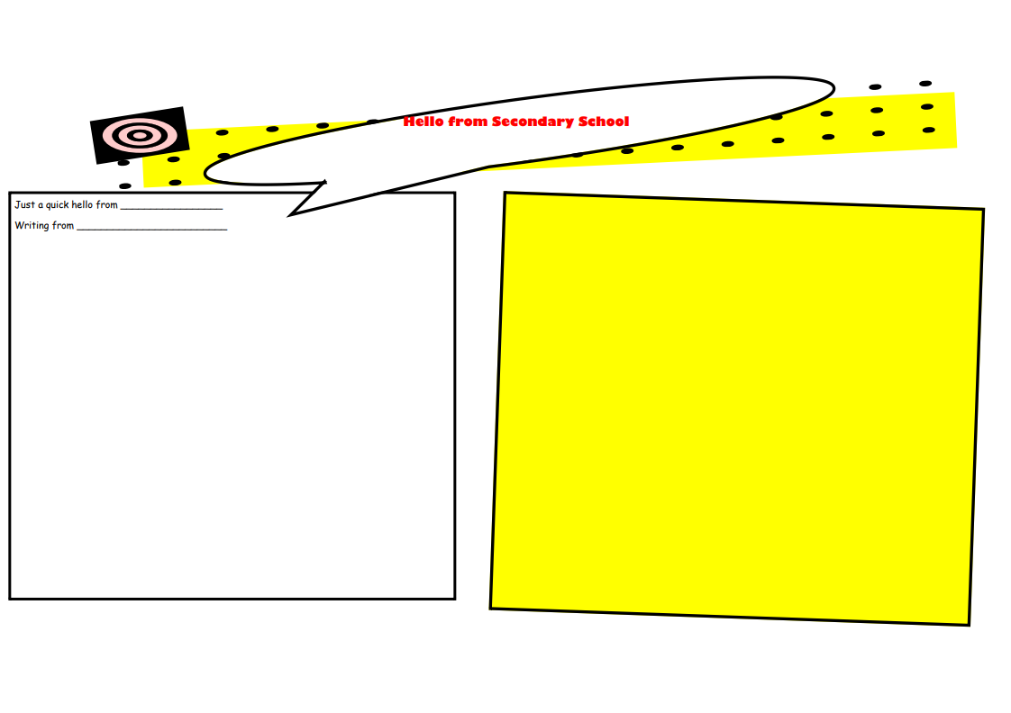

Chellaston Academy

Charlie Yeomans

That way I have enough time to complete my homework and have time to relax at home. You will be given a timetable which has your lessons for 2 weeks ahead, then the timetable repeats itself over again.

A regular day consists of this plan:

1st period - 2nd period – Break – 3rd period – 4th period – Lunch – 5th period – End of day

Lessons start at 9 am and finish at 3 pm, so you don’t have that long at school.

I hope you settle in nice and have a good first few weeks when you start.

Take care.

Bye.

Hi Year 6,

I hope you have a good transition into secondary school and enjoy your time there.

When I had my first induction day I was really nervous as I didn’t know anyone there but then I made some friends and felt safe. Then I started to get to know the school and where everything was so I was ready for my first few weeks. When I first started at Chellaston the buildings seem to be really big but after a few weeks I realised it wasn’t as big as it first looked.

Everyone is really nice and helpful so don’t be shy or afraid to approach them for help. In your first few weeks you might get lost but you are supplied with a map for guidance but after a couple of weeks you probably won’t need it. There are multiple food areas spread around the grounds for lunch and break times which you pay with using a fingerprint scanner. You will have a Wisepay account set up where you take your fingerprint and set up a bank which you top up at home. The Firefly website is the main homework page where you will make an email and have teachers set you homework and tasks which have to be completed by a set date but you don’t get that much and it is set for about a week ahead so you have a long time to complete them. When I get homework I log on as soon as I get home and complete any homework due within 7 days.