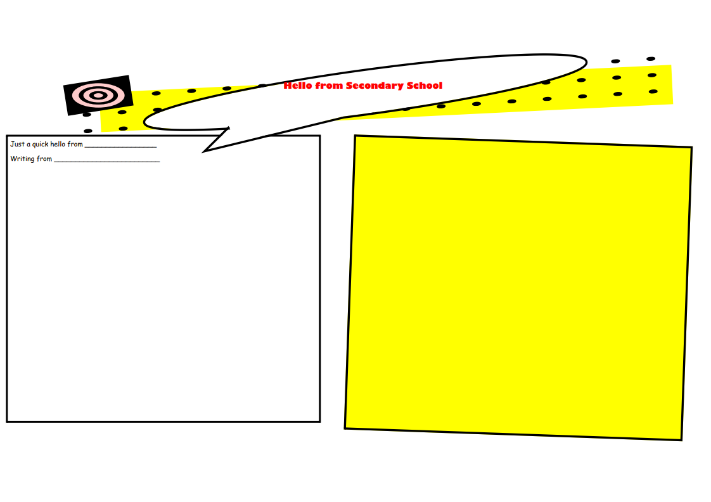

Chellaston Academy

Joshua Rankin

Homework, you would normally get set this nearly everyday by your teachers sometimes it is a bit tricky! But if you needed any help with your homework you could email your subject teacher or you could go to homework club which is open at 7am i think and in that time you can do your homework then and get help. You would normally start school at 9am and finish at 3pm but you have to be in school by 8:30am! I am certainly sure that you will settle in pretty well thanks for reading and bye!

Hi Year 6 I hope you will have a good transition when this is all over! The school is massive so it is easy to get lost but don’t worry about that because we are here to help you settle in if you do get lost you could always ask a teacher or another student trust me the teachers are really nice also on your first day depending on if your teaching or learning you can go to lunch at quarter to one!!! Trust me the food is amazing and also at break times the food cube is also open so you could get a pizza, a Cinnamon swirl they are my favourite, also you could get a Croissant e.g. The best day of the week to have school dinners is Friday because it is chicken burgers trust me THEY ARE AMAZING!!! Also on Friday you could get chips as well also you could buy a cookie which are incredible!!