**Transition work answers**

**Pre-Knowledge Topics Answers to problems**

Q1.1a) 1s2 2s2 2p63s23p64s2 b) 1s2 2s2 2p63s23p1 c) 1s2 2s2 2p63s23p4 d) 1s2 2s2 2p63s23p5

e) 1s2 2s2 2p63s23p6 f) 1s2 2s2 2p63s23p6 3d64s2  g) 1s2 2s2 2p63s23p6 3d34s2

h) 1s2 2s2 2p63s23p6 3d84s2 i) 1s2 2s2 2p63s23p6 3d10 4s1 j) 1s2 2s2 2p63s23p6 3d10 4s2

k) 1s2 2s2 2p63s23p64s2 3d10 4p3

Q1.2a) 1s2 2s2 2p63s23p6 b) 1s2 2s2 2p63s23p6 c) 1s2 2s2 2p63s23p6 3d10

d) 1s2 2s2 2p63s23p6 e) 1s2 2s2 2p63s23p6 3d7

==========================================================================================

Q2.1 a) +4 b) +6 c) +5 d) +4 e) +3 f) +5 g) +7 h) +6 i) +4

==========================================================================================

Q3.1 They must be ionised / turned into ions

Q3.2 The ions are all given the same amount of kinetic energy, as KE = ½ mv2 the lighter ions will have greater speed / heavier ions will have less speed.

Q3.3 a) 121.855 b) 67.796 c) 107.973 d) 204.41 e) 87.710 / 87.7102

==========================================================================================

Q4.1

a) 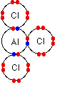 120o b) 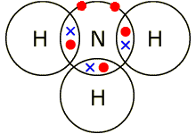107o c) 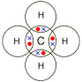109.5o

==========================================================================================

Q5a. 2H2 + 02🡪 2 H20

b. S8+ 1202🡪 8S03

c. 2HgO 🡪 2Hg+ 02

d. Zn+ 2HCl🡪 ZnCl2+ H2

e. 2Na+ 2H20 🡪 2NaOH + H2

f. C10H16+ 8CI2 🡪 10C + 16HCl

g. 2Fe+ 302🡪 2Fe203

h. C6H1206+ 602🡪 6 C02+ 6 H20

i. Fe203 + 3H2 🡪 2Fe + 3H20

j. 2Al + 3 FeO 🡪 Al2O3 + 3Fe

Q6.1 a) 85.2/284 = 0.3 moles b) 73.56/122.6 = 0.6 moles c) 249.5/249.5 = 1.0 moles

d) 0.125 x 212.8 = 26.6g e) 2Mg : 2O or 1:1 ratio 2.4g of Mg = 0.1moles so we need 0.1 moles of oxygen (O2): 0.1 x 32 = 3.2g

7.1 a) 9.53g/95.3 = 0.1 moles, in 100cm3 or 0.1dm3 in 1dm3 0.1moles/0.1dm3 = 1.0 mol dm-3

b) 13.284g/331.2 = 0.04 moles, in 2dm3 in 1dm3 0.04moles /2dm3 = 0.02 mol dm-3

c) 100cm3  of 0.1 mol dm-3 = 0.01 moles added to a total volume of 2 dm3 = 0.01moles/2dm3 = 0.005 mol dm-3

d) in 1dm3 of 1 mol dm-3 silver nitrate, 1 mole of Ag = 107.9g in 0.1dm3 = 107.9 x 0.1 = 10.79g

e) 0.0526 x 79.7 = 42.0274g

==========================================================================================

8.1

Ba(NO3)2 : Na2SO4

1 : 1 ratio

12.5cm3 of Ba(NO3)2 = 0.0125dm3

0.15 moldm-3 x 0.0125dm3 = 0.001875 moles

same number of moles of sodium sulfate needed, which has a concentration of 0.25 mol dm-3

0.001875 moles / 0.25 mol dm-3 = 0.0075 dm3 or 7.5cm3

==========================================================================================

9.1 1-chlorobutane

Add butan-1-ol to concentrated HCl and shake

9.2 react ethene with hydrogen gas at high temperature and pressure with a nickel catalyst

The reaction is similar in that it releases hydrogen but different as it proceeds much slower than in water

9.3 propanal propanone

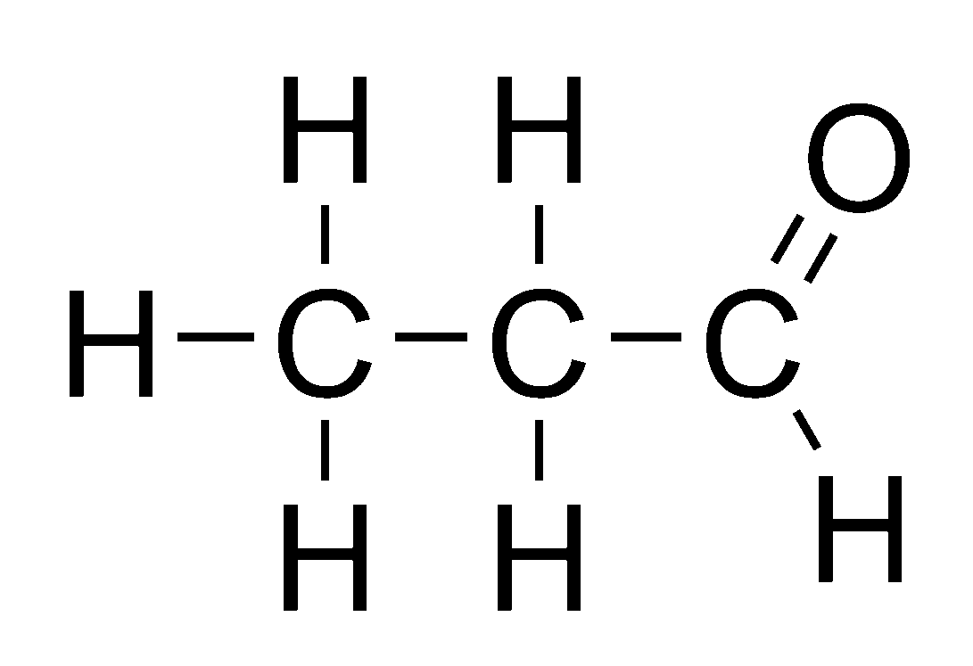 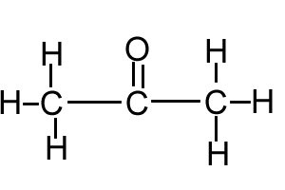

The carbon atom joined to oxygen in propanal has a hydrogen attached to it, it does not in propanone.

==========================================================================================

10.1 An acid is a proton donor

10.2 Ammonia can accept a proton, to become NH4+

10.3 ethanoic acid has not fully dissociated, it has not released all of its hydrogen ions into the solution.

CH3COOH ⇋ CH3COO - + H+

Mostly this Very few of these

10.4 pH = -log [0.01] = 2 The pH = 2

**Chemistry A level transition - baseline assessment. - Answers**

1. .
   1. Which is the correct electron configuration for a nitrogen atom, circle the correct answer [1]

1s22p5  1s12p6 1s22s22p3 1s22s5 1s22s22p63s23p2

* 1. Which is the correct electron configuration for a chlorine atom, circle the correct answer [1]

1s22s82p7 1s22s22p82d5 1s22s22p63d7 1s22s22p63p7 1s22s22p63s23p5

* 1. Which is the correct electron configuration for an aluminium **ion**, Al3+? Circle the correct answer [1]

1s22s22p6 1s22s22p63s23p3 1s22s22p63s2 1s22s22p62d1

1. Draw a dot and cross diagram to show the bonding in a molecule of water, H2O. [2]

Atomic numbers: H =1, O =8

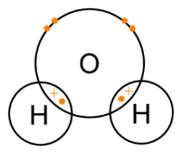

1 mark for 2 x shared electrons

1 mark for lone pairs

1. A time of flight mass spectrometer has 4 main stages. put the correct stage in the diagram below:

**Drift region**

**Ionisation**



[4]

**Detector**

**Acceleration**

1. A mass spectrometer was used to analyse a sample of chlorine, the results of the analysis are as follows:

(35x75.53) + (37x24.47)/100 [1]

= 35.4894 [1]

To 3dp = 35.489 [1] [2 marks if above line is missing]

|  |  |
| --- | --- |
| isotope mass | % of sample |
| Cl-35 | 75.53 |
| Cl-37 | 24.47 |

[3]

1. Give the oxidation state of the underlined atom in the following chemicals.

Useful information: H = +1, K = +1, Na = +1, Mg = +2, O = -2, Cl = -1 [7]

a) CO2 +4 b) SO3 +6 c) H2SO4 +6 d) AlCl3 +3

e) Cr2O3 +3 f) NaNO3 +5g) VCl4 +4

1. Balance the following chemical equations:

a) C3H8 + _5_ O2 🡪 ­_3_ CO2 + _4_ H2O [3]

b) ­_2_ HCl + Mg(OH)2 🡪 MgCl2 + _2_ H2O [2]

c) Na2CO3 + _2_ H­Cl 🡪 _2_ NaCl + _1_ H2O + CO2 [3]

1. Calculate the relative formula masses of the following:

Atomic masses: H = 1, O = 16, S = 32.1, C = 12, Ca = 40.1, Na = 23, Cl = 35.5

a) CaCl2 b) H2CO3 c) Na2SO4 d) C3H7OH e) Zn(NO3)2 [5]

111.1 62 142.3 60 189.4

1. A student carried out a reaction with this molecule:

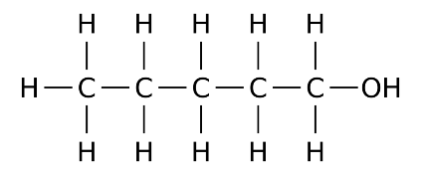

a. What is the name of this molecule? pentan-1-ol [2]

Pentanol = 1 mark pentan-1-ol = 2 marks

1. Using the chemical equation, how many moles of sodium hydroxide will react with 1 mole of ethanoic acid?

_____1_____moles [1]

1. How many moles of sodium hydroxide are in 27.50cm3 of 1.00 moldm-3 sodium hydroxide?

27.5/1000 [1] x 1.00 = 0.0275 [1]

0.0275 [2] moles [2]

1. How many moles of ethanoic acid are in 25.0cm3 of the vinegar sample?

___0.0275 __moles [1]

1. How many moles of ethanoic acid are in 1dm3 of vinegar?

0.0275 x 1000/25 = 1.10

___1.10____moles [1]

1. Ethanoic acid has a formula mass of 48. What mass of ethanoic acid is present in 1dm3 of vinegar?

1.1 x 48 = 52.8g

___52.8g ___g [1]