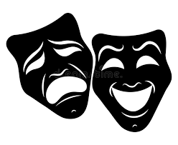

Year 6 Transition

Work Booklet

Drama

Name……………………………………………………………

Primary School…………………………………………….

 

**Drama**

1. Who are your 3 favourite actors/actresses? What do you like about them?

………………………………………………………………………………………………………………………………………………………………………………………………………………………………………………………………………………………………………………………………………………………………………………………………………………

1. What are your 3 favourite films? Why do you like them?

……………………………………………………………………………………………………………………………………………………………………………………………………………………………………………………………………………………………………………………………………………………………………………………………………………………………

1. What are your 3 favourite stories/books? What is your favourite thing about them?

……………………………………………………………………………………………………………………………………………………………………………………………………………………………………………………………………………………………………………………………………………………………………………………………………………………………......................................................

1. Watch one episode of your favourite TV show. When watching, pick one character to focus on. Answer the following questions:

* How is your character feeling during this episode? (It could be angry, happy, excited or sad)

………………………………………………………………………………………………………………………………………………………………………………………………………………………………

* What has helped you to know how the character is feeling? (it might be the music, what the characters say, their costume or something else!)

………………………………………………………………………………………………………………………………………………………………………………………………………………………………



**A Night at the Theatre**

Here is how you can create your very own night at the theatre at home!

1. There is an extract from ‘Ernie’s Incredible illucinations’ below. Read through the extract with someone you live with.

2. Once you have read through the script. Consider how you might perform the extract to an audience – Use family members to play the other characters (Remember never have your back to the audience!)

3. Next can you think about any costume you might use for the characters in the extract? You might even want to add some sound?

4. Finally use all your preparation to put on your own night at the theatre from home!

Ernie’s incredible imagination is alarming his parents. They go to the doctor in search of a cure. Once they are there, they discover Ernie’s ‘illucinations’ are more powerful than they realised. Everything Ernie imagines – from secret agents to a boxing granny – becomes real!

**Referee** (*quietening the crowd)* And now, ladies and gentlemen, the Kid wishes to issue a challenge to any person here who would like to try his skill at lasting three rounds - any person here. Come along now - anybody care to try ...

*Muttering from the Crowd*

**Auntie** (to the ,Man) Go on then.

**Man** Who, me?

**Auntie** What are you frightened of, then?

**Man** I'm frightened of him ...

**Referee** Come along now. We're not asking you to do it for nothing. We're offering fifty pounds - fifty pounds, gentlemen.

**Auntie** Go on. Fifty quid.

**Man** I'd need that to pay the hospital bill. . .

**Auntie** Go on

**Man** It's all right for you, lady-just standing there telling other people to go and get their noses broken.

**Auntie** All right, then. I'll go in myself Excuse me. . . (She starts to push through the Crowd towards the ring)

**Man** Hey ...

**Ernie** Auntie, where are you going?

**Auntie** Out of my way ...

**Man** Hey, stop her - she's off her nut...

**Ernie** Auntie!

**Auntie** (*hailing the Referee)* Hey, you...

**Referee** Hallo, lady, what can we do for you? Come to challenge him, have you?

*Laughter from the Crowd*

**Auntie** That's right. Help me in.

**Refere**e Just a minute, lady, you've come the wrong way for the jumble sale, this is a boxing-ring ...

**Auntie** I know what it is. Wipe that silly smile off your face. Come on then, rings out of your seconds ...

*The Crowd cheers*

**Referee** Just a minute. Just a minute. What do you think you're playing at ... ?

**Auntie** You said anyone could have a go, didn't you?

**Woman** That's right. Give her a go, then.

Referee (*getting worried*) Now, listen ...

**Kid Saracen** Go home. There's a nice old lady ...

*The Crowd boos*

**Auntie** You cheeky ha'porth.

**Second Man** Hit him, grandma.

**Referee** Tell you what, folks. Let's give the old lady fifty pence for being a good sport

**Auntie** I don't want your fifty pence. . . Come on.

**Woman** Get the gloves on, granny.

**Auntie** I don't need gloves. My hands have seen hard work. I was scrubbing floors before he was thought of ...Woman That's right, love.

**Ernie** *(stepping forward)* And then suddenly I got this idea. Maybe Auntie May could be the new heavyweight champion of the world ...

*The bell rings. Auntie May comes bouncing out of her corner flinging punches at the Kid, who looks startled.*

**Auntie** Let's have you.

**Kid Saracen** Hey, come off it!

*The Referee tries vainly to pull Auntie May back but she dances out of reach*

**Kid Saracen** Somebody chuck her out.

*The Kid turns to appeal to the Crowd. Auntie May punches him in the back*

**Auntie** Gotcher!

**Kid Saracen** Ow!

*Auntie May bombards the Kid with punches*

**Ernie** *(commentator style)* And Auntie May moves in again and catches the Kid with a left and a right to the body and there's a right-cross to the head - and that really hurt him - and it looks from here as if the champ is in real trouble ... as this amazing sixty-eight-year-old challenger follows up with a series of sharp left-jabs-one, two, three, four jabs .

*The Kid is reeling back*

And then, bang, a right-hook and he's down ...!

*The Kid goes down on his knees. The Crowd cheers*

**Auntie** *(to the Referee)* Go on. Start counting.

**Crowd** One-two-three-four-five-six

*The Kid gets up again*

**Ernie** And the Kid's on his feet but he's no idea where he is - and there's that tremendous right uppercut - and he's down again . . .

*The Crowd counts him out. Auntie May dances round the ring with glee. The Crowd bursts into the ring and Auntie May is lifted on to their shoulders The Crowd go out with A untie May, singing "For She's a Jolly Good Fellow" The Referee and the Kid are left*

**Referee** Come on. Get up – champ.

**Kid Saracen.** Ooooh*. (He staggers to his feet.)*

*The Kid goes out, supported by the Referee*

Still Image Challenge

**Task 1**

Think of a scene from a film, play or musical. Make sure it is visual and engaging.

For example, below is a scene from Star Wars.

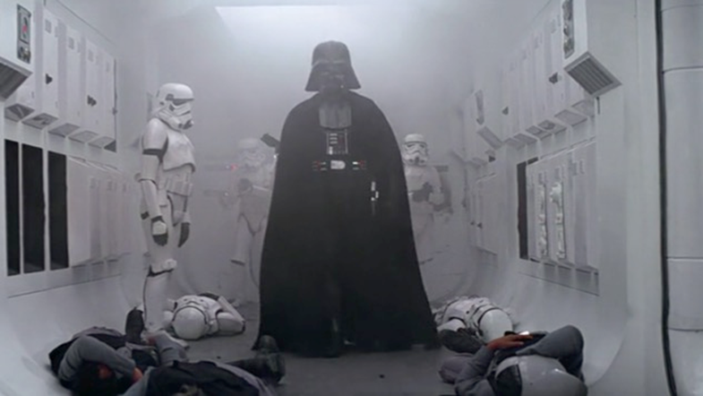

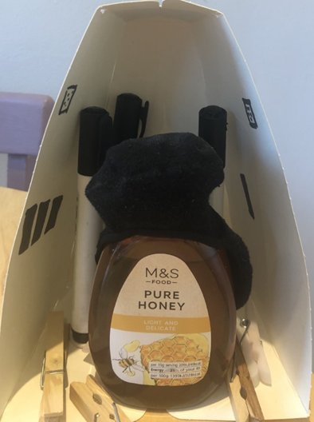Then I want you to try to recreate it as accurately as possible using objects from around your home.

For this I used an Easter egg box, marker pens, clothes pegs, a jar of honey and a sock.

The film/play/musical I have chosen is

________________________________________________________________

I have chosen this because ________________________________________________________________________________________________________________________________

Here is the original scene:

Here is my recreation of the scene:

**Evaluation**

List three things about your picture you are happy with.

1. ___________________________________________________________

2. ___________________________________________________________

3. ___________________________________________________________

Say one thing you would improve if you did this task again.

________________________________________________________________

Which part of this task did you find difficult of challenging?

________________________________________________________________________________________________________________________________________________________________________________________________

**Task 2**

Also using everyday items from around your home, create several Still images to tell a story. You should have at least three – which could show beginning middle and end.