**Approaches in Psychology**

1. Internet research:

Do read up on ‘Approaches in Psychology’ (different ways of explaining behaviour):

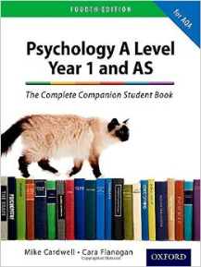There will be an exam on this material in the first few weeks of ‘AS’!

|  |  |  |  |
| --- | --- | --- | --- |
|  | Biological Approach | Behavioural Approach | Cognitive Approach |
| Key terms/names of researchers/theorists |  |  |  |
| What causes behaviour according to this approach? |  |  |  |
| ☺ Strengths (+ points) |  |  |  |
| ☹ Weaknesses (- points) |  |  |  |

1. Find a newspaper article that links to a topic you will be studying in A-level Psychology and try to apply one of the explanations above to this – write a summary paragraph.

**TEXTBOOK: Psychology A Level Year 1 and AS: The Complete Companion Student Book (5th Edition - 2018) – Cardwell & Flanagan ISBN: 978-0198436324 £24.71 (ish)**